14 DAY MEAL PLANS AND
GROCERY LISTS
Keto Meal Plan

Contents

BREAK”FASTS”
Eggs Florentine Casserole |  |  |  |  |  |  |  |  |  |  |  |  |  |  |  |  |  |  |  |  |  |  |  |  |  |  |  |  |  |  |  |  |  |  |  |  |  |  |  |  |  |  |  |  |  |  |  |  |  |  |  |  |  |  |  |  |  | 6
Pizza Deviled Eggs |  |  |  |  |  |  |  |  |  |  |  |  |  |  |  |  |  |  |  |  |  |  |  |  |  |  |  |  |  |  |  |  |  |  |  |  |  |  |  |  |  |  |  |  |  |  |  |  |  |  |  |  |  |  |  |  |  | 7
Open Faced Breakfast Sandwich |  |  |  |  |  |  |  |  |  |  |  |  |  |  |  |  |  |  |  |  |  |  |  |  |  |  |  |  |  |  |  |  |  |  |  |  |  |  |  |  |  |  |  |  |  |  |  |  |  |  |  |  |  |  |  |  |  | 8
Gyro Breakfast Patties |  |  |  |  |  |  |  |  |  |  |  |  |  |  |  |  |  |  |  |  |  |  |  |  |  |  |  |  |  |  |  |  |  |  |  |  |  |  |  |  |  |  |  |  |  |  |  |  |  |  |  |  |  |  |  |  |  | 9
Dairy Free & Nut Free Pancakes |  |  |  |  |  |  |  |  |  |  |  |  |  |  |  |  |  |  |  |  |  |  |  |  |  |  |  |  |  |  |  |  |  |  |  |  |  |  |  |  |  |  |  |  |  |  |  |  |  |  |  |  |  |  |  |  |  | 10
Chocolate French Toast |  |  |  |  |  |  |  |  |  |  |  |  |  |  |  |  |  |  |  |  |  |  |  |  |  |  |  |  |  |  |  |  |  |  |  |  |  |  |  |  |  |  |  |  |  |  |  |  |  |  |  |  |  |  |  |  |  | 11
SAUCES AND CONDIMENTS
Green Goddess Dressing |  |  |  |  |  |  |  |  |  |  |  |  |  |  |  |  |  |  |  |  |  |  |  |  |  |  |  |  |  |  |  |  |  |  |  |  |  |  |  |  |  |  |  |  |  |  |  |  |  |  |  |  |  |  |  |  |  |  | 14
Dairy Free Hollandaise |  |  |  |  |  |  |  |  |  |  |  |  |  |  |  |  |  |  |  |  |  |  |  |  |  |  |  |  |  |  |  |  |  |  |  |  |  |  |  |  |  |  |  |  |  |  |  |  |  |  |  |  |  |  |  |  |  |  | 15
Keto Tortilla Wraps |  |  |  |  |  |  |  |  |  |  |  |  |  |  |  |  |  |  |  |  |  |  |  |  |  |  |  |  |  |  |  |  |  |  |  |  |  |  |  |  |  |  |  |  |  |  |  |  |  |  |  |  |  |  |  |  |  |  | 16
Red Chile Sauce |  |  |  |  |  |  |  |  |  |  |  |  |  |  |  |  |  |  |  |  |  |  |  |  |  |  |  |  |  |  |  |  |  |  |  |  |  |  |  |  |  |  |  |  |  |  |  |  |  |  |  |  |  |  |  |  |  |  | 17
RED CURRY DIPPING SAUCE |  |  |  |  |  |  |  |  |  |  |  |  |  |  |  |  |  |  |  |  |  |  |  |  |  |  |  |  |  |  |  |  |  |  |  |  |  |  |  |  |  |  |  |  |  |  |  |  |  |  |  |  |  |  |  |  |  |  | 18
Cilantro Lime Sauce |  |  |  |  |  |  |  |  |  |  |  |  |  |  |  |  |  |  |  |  |  |  |  |  |  |  |  |  |  |  |  |  |  |  |  |  |  |  |  |  |  |  |  |  |  |  |  |  |  |  |  |  |  |  |  |  |  |  | 19
Dairy Free Ranch Dressing |  |  |  |  |  |  |  |  |  |  |  |  |  |  |  |  |  |  |  |  |  |  |  |  |  |  |  |  |  |  |  |  |  |  |  |  |  |  |  |  |  |  |  |  |  |  |  |  |  |  |  |  |  |  |  |  |  |  | 20
Buffalo Wing Sauce |  |  |  |  |  |  |  |  |  |  |  |  |  |  |  |  |  |  |  |  |  |  |  |  |  |  |  |  |  |  |  |  |  |  |  |  |  |  |  |  |  |  |  |  |  |  |  |  |  |  |  |  |  |  |  |  |  |  | 21
Dairy Free Chocolate Drizzle |  |  |  |  |  |  |  |  |  |  |  |  |  |  |  |  |  |  |  |  |  |  |  |  |  |  |  |  |  |  |  |  |  |  |  |  |  |  |  |  |  |  |  |  |  |  |  |  |  |  |  |  |  |  |  |  |  |  | 22
Dairy Free Cinnamon Syrup |  |  |  |  |  |  |  |  |  |  |  |  |  |  |  |  |  |  |  |  |  |  |  |  |  |  |  |  |  |  |  |  |  |  |  |  |  |  |  |  |  |  |  |  |  |  |  |  |  |  |  |  |  |  |  |  |  |  | 23
Keto Egg Bread |  |  |  |  |  |  |  |  |  |  |  |  |  |  |  |  |  |  |  |  |  |  |  |  |  |  |  |  |  |  |  |  |  |  |  |  |  |  |  |  |  |  |  |  |  |  |  |  |  |  |  |  |  |  |  |  |  |  | 24
SIDE DISHES  Parmesan Basil Asparagus |  |  |  |  |  |  |  |  |  |  |  |  |  |  |  |  |  |  |  |  |  |  |  |  |  |  |  |  |  |  |  |  |  |  |  |  |  |  |  |  |  |  |  |  |  |  |  |  |  |  |  |  |  |  |  |  |  |  | 28
Buffalo Chicken Wings |  |  |  |  |  |  |  |  |  |  |  |  |  |  |  |  |  |  |  |  |  |  |  |  |  |  |  |  |  |  |  |  |  |  |  |  |  |  |  |  |  |  |  |  |  |  |  |  |  |  |  |  |  |  |  |  |  |  | 29
Halibut Red Curry |  |  |  |  |  |  |  |  |  |  |  |  |  |  |  |  |  |  |  |  |  |  |  |  |  |  |  |  |  |  |  |  |  |  |  |  |  |  |  |  |  |  |  |  |  |  |  |  |  |  |  |  |  |  |  |  |  |  | 30
Asparagus Cobb Salad |  |  |  |  |  |  |  |  |  |  |  |  |  |  |  |  |  |  |  |  |  |  |  |  |  |  |  |  |  |  |  |  |  |  |  |  |  |  |  |  |  |  |  |  |  |  |  |  |  |  |  |  |  |  |  |  |  |  | 31
CREAMY CHICKEN SOUP |  |  |  |  |  |  |  |  |  |  |  |  |  |  |  |  |  |  |  |  |  |  |  |  |  |  |  |  |  |  |  |  |  |  |  |  |  |  |  |  |  |  |  |  |  |  |  |  |  |  |  |  |  |  |  |  |  |  | 32
MAIN DISHES  Salmon with Crispy Skin |  |  |  |  |  |  |  |  |  |  |  |  |  |  |  |  |  |  |  |  |  |  |  |  |  |  |  |  |  |  |  |  |  |  |  |  |  |  |  |  |  |  |  |  |  |  |  |  |  |  |  |  |  |  |  |  |  |  | 36
Crab Claw Curry “Rice” |  |  |  |  |  |  |  |  |  |  |  |  |  |  |  |  |  |  |  |  |  |  |  |  |  |  |  |  |  |  |  |  |  |  |  |  |  |  |  |  |  |  |  |  |  |  |  |  |  |  |  |  |  |  |  |  |  |  | 37
Kentucky Hot Brown |  |  |  |  |  |  |  |  |  |  |  |  |  |  |  |  |  |  |  |  |  |  |  |  |  |  |  |  |  |  |  |  |  |  |  |  |  |  |  |  |  |  |  |  |  |  |  |  |  |  |  |  |  |  |  |  |  |  | 38
Camaron en Chile Rojo |  |  |  |  |  |  |  |  |  |  |  |  |  |  |  |  |  |  |  |  |  |  |  |  |  |  |  |  |  |  |  |  |  |  |  |  |  |  |  |  |  |  |  |  |  |  |  |  |  |  |  |  |  |  |  |  |  |  | 40
Shrimp Arrabbiata |  |  |  |  |  |  |  |  |  |  |  |  |  |  |  |  |  |  |  |  |  |  |  |  |  |  |  |  |  |  |  |  |  |  |  |  |  |  |  |  |  |  |  |  |  |  |  |  |  |  |  |  |  |  |  |  |  |  | 41
Halibut with Spring |  |  |  |  |  |  |  |  |  |  |  |  |  |  |  |  |  |  |  |  |  |  |  |  |  |  |  |  |  |  |  |  |  |  |  |  |  |  |  |  |  |  |  |  |  |  |  |  |  |  |  |  |  |  |  |  |  |  | 42
Walkin Tacos |  |  |  |  |  |  |  |  |  |  |  |  |  |  |  |  |  |  |  |  |  |  |  |  |  |  |  |  |  |  |  |  |  |  |  |  |  |  |  |  |  |  |  |  |  |  |  |  |  |  |  |  |  |  |  |  |  |  | 43
Deep Dish Dutch Baby Pizza |  |  |  |  |  |  |  |  |  |  |  |  |  |  |  |  |  |  |  |  |  |  |  |  |  |  |  |  |  |  |  |  |  |  |  |  |  |  |  |  |  |  |  |  |  |  |  |  |  |  |  |  |  |  |  |  |  | 44
Open-Faced Chicken Pesto Sandwich |  |  |  |  |  |  |  |  |  |  |  |  |  |  |  |  |  |  |  |  |  |  |  |  |  |  |  |  |  |  |  |  |  |  |  |  |  |  |  |  |  |  |  |  |  |  |  |  |  |  |  |  |  |  |  |  |  | 45
Chicken with Mushroom Gravy |  |  |  |  |  |  |  |  |  |  |  |  |  |  |  |  |  |  |  |  |  |  |  |  |  |  |  |  |  |  |  |  |  |  |  |  |  |  |  |  |  |  |  |  |  |  |  |  |  |  |  |  |  |  |  |  |  | 46
Filet Mignon With Olive Salad |  |  |  |  |  |  |  |  |  |  |  |  |  |  |  |  |  |  |  |  |  |  |  |  |  |  |  |  |  |  |  |  |  |  |  |  |  |  |  |  |  |  |  |  |  |  |  |  |  |  |  |  |  |  |  |  |  | 47
TANDOORI GRILLED SHRIMP |  |  |  |  |  |  |  |  |  |  |  |  |  |  |  |  |  |  |  |  |  |  |  |  |  |  |  |  |  |  |  |  |  |  |  |  |  |  |  |  |  |  |  |  |  |  |  |  |  |  |  |  |  |  |  |  |  | 48
Cilantro Lime Pork Chops |  |  |  |  |  |  |  |  |  |  |  |  |  |  |  |  |  |  |  |  |  |  |  |  |  |  |  |  |  |  |  |  |  |  |  |  |  |  |  |  |  |  |  |  |  |  |  |  |  |  |  |  |  |  |  |  |  | 49
Cilantro Lime Slow Cooker Pork Short Ribs 50

Hot and Spicy Chicken Chorizo Chili |  |  |  |  |  |  |  |  |  |  |  |  |  |  |  |  |  |  |  |  |  |  |  |  |  |  |  |  |  |  |  |  |  |  |  |  |  |  |  |  |  |  |  |  |  |  |  |  |  |  |  |  |  |  |  |  |  | 51
Trout Provencale en papillote |  |  |  |  |  |  |  |  |  |  |  |  |  |  |  |  |  |  |  |  |  |  |  |  |  |  |  |  |  |  |  |  |  |  |  |  |  |  |  |  |  |  |  |  |  |  |  |  |  |  |  |  |  |  |  |  |  | 52
Lamb and Mushroom Kabobs |  |  |  |  |  |  |  |  |  |  |  |  |  |  |  |  |  |  |  |  |  |  |  |  |  |  |  |  |  |  |  |  |  |  |  |  |  |  |  |  |  |  |  |  |  |  |  |  |  |  |  |  |  |  |  |  |  | 53
DESSERTS  Mexican Chocolate SemiFreddo |  |  |  |  |  |  |  |  |  |  |  |  |  |  |  |  |  |  |  |  |  |  |  |  |  |  |  |  |  |  |  |  |  |  |  |  |  |  |  |  |  |  |  |  |  |  |  |  |  |  |  |  |  |  |  |  |  | 56
Chocolate Cheesecake Trifle |  |  |  |  |  |  |  |  |  |  |  |  |  |  |  |  |  |  |  |  |  |  |  |  |  |  |  |  |  |  |  |  |  |  |  |  |  |  |  |  |  |  |  |  |  |  |  |  |  |  |  |  |  |  |  |  |  |  | 57
Chai Tea Breakfast Custard |  |  |  |  |  |  |  |  |  |  |  |  |  |  |  |  |  |  |  |  |  |  |  |  |  |  |  |  |  |  |  |  |  |  |  |  |  |  |  |  |  |  |  |  |  |  |  |  |  |  |  |  |  |  |  |  |  |  | 58
Vanilla bean cupcakes |  |  |  |  |  |  |  |  |  |  |  |  |  |  |  |  |  |  |  |  |  |  |  |  |  |  |  |  |  |  |  |  |  |  |  |  |  |  |  |  |  |  |  |  |  |  |  |  |  |  |  |  |  |  |  |  |  |  | 59
Chocolate Angel food Cake |  |  |  |  |  |  |  |  |  |  |  |  |  |  |  |  |  |  |  |  |  |  |  |  |  |  |  |  |  |  |  |  |  |  |  |  |  |  |  |  |  |  |  |  |  |  |  |  |  |  |  |  |  |  |  |  |  |  | 60
Easy Flourless Cookies |  |  |  |  |  |  |  |  |  |  |  |  |  |  |  |  |  |  |  |  |  |  |  |  |  |  |  |  |  |  |  |  |  |  |  |  |  |  |  |  |  |  |  |  |  |  |  |  |  |  |  |  |  |  |  |  |  |  | 61
MEAL PLANS  Meal Plan Week 1 |  |  |  |  |  |  |  |  |  |  |  |  |  |  |  |  |  |  |  |  |  |  |  |  |  |  |  |  |  |  |  |  |  |  |  |  |  |  |  |  |  |  |  |  |  |  |  |  |  |  |  |  |  |  |  |  |  |  | 64
Day 1 |  |  |  |  |  |  |  |  |  |  |  |  |  |  |  |  |  |  |  |  |  |  |  |  |  |  |  |  |  |  |  |  |  |  |  |  |  |  |  |  |  |  |  |  |  |  |  |  |  |  |  |  |  |  |  |  |  |  | 64
Day 2 |  |  |  |  |  |  |  |  |  |  |  |  |  |  |  |  |  |  |  |  |  |  |  |  |  |  |  |  |  |  |  |  |  |  |  |  |  |  |  |  |  |  |  |  |  |  |  |  |  |  |  |  |  |  |  |  |  |  | 64
Day 3 |  |  |  |  |  |  |  |  |  |  |  |  |  |  |  |  |  |  |  |  |  |  |  |  |  |  |  |  |  |  |  |  |  |  |  |  |  |  |  |  |  |  |  |  |  |  |  |  |  |  |  |  |  |  |  |  |  |  | 64
Day 4 |  |  |  |  |  |  |  |  |  |  |  |  |  |  |  |  |  |  |  |  |  |  |  |  |  |  |  |  |  |  |  |  |  |  |  |  |  |  |  |  |  |  |  |  |  |  |  |  |  |  |  |  |  |  |  |  |  |  | 64
Meal Plan Week 1 cont |  |  |  |  |  |  |  |  |  |  |  |  |  |  |  |  |  |  |  |  |  |  |  |  |  |  |  |  |  |  |  |  |  |  |  |  |  |  |  |  |  |  |  |  |  |  |  |  |  |  |  |  |  |  |  |  |  |  | 65
Day 5 |  |  |  |  |  |  |  |  |  |  |  |  |  |  |  |  |  |  |  |  |  |  |  |  |  |  |  |  |  |  |  |  |  |  |  |  |  |  |  |  |  |  |  |  |  |  |  |  |  |  |  |  |  |  |  |  |  |  | 65
Day 6 |  |  |  |  |  |  |  |  |  |  |  |  |  |  |  |  |  |  |  |  |  |  |  |  |  |  |  |  |  |  |  |  |  |  |  |  |  |  |  |  |  |  |  |  |  |  |  |  |  |  |  |  |  |  |  |  |  |  | 65
Day 7 |  |  |  |  |  |  |  |  |  |  |  |  |  |  |  |  |  |  |  |  |  |  |  |  |  |  |  |  |  |  |  |  |  |  |  |  |  |  |  |  |  |  |  |  |  |  |  |  |  |  |  |  |  |  |  |  |  |  | 65
Grocery List Week 1 |  |  |  |  |  |  |  |  |  |  |  |  |  |  |  |  |  |  |  |  |  |  |  |  |  |  |  |  |  |  |  |  |  |  |  |  |  |  |  |  |  |  |  |  |  |  |  |  |  |  |  |  |  |  |  |  |  |  | 66
Meal Plan Week 2 |  |  |  |  |  |  |  |  |  |  |  |  |  |  |  |  |  |  |  |  |  |  |  |  |  |  |  |  |  |  |  |  |  |  |  |  |  |  |  |  |  |  |  |  |  |  |  |  |  |  |  |  |  |  |  |  |  |  | 68
Day 1 |  |  |  |  |  |  |  |  |  |  |  |  |  |  |  |  |  |  |  |  |  |  |  |  |  |  |  |  |  |  |  |  |  |  |  |  |  |  |  |  |  |  |  |  |  |  |  |  |  |  |  |  |  |  |  |  |  |  | 68
Day 2 |  |  |  |  |  |  |  |  |  |  |  |  |  |  |  |  |  |  |  |  |  |  |  |  |  |  |  |  |  |  |  |  |  |  |  |  |  |  |  |  |  |  |  |  |  |  |  |  |  |  |  |  |  |  |  |  |  |  | 68
Day 3 |  |  |  |  |  |  |  |  |  |  |  |  |  |  |  |  |  |  |  |  |  |  |  |  |  |  |  |  |  |  |  |  |  |  |  |  |  |  |  |  |  |  |  |  |  |  |  |  |  |  |  |  |  |  |  |  |  |  | 68
Day 4 |  |  |  |  |  |  |  |  |  |  |  |  |  |  |  |  |  |  |  |  |  |  |  |  |  |  |  |  |  |  |  |  |  |  |  |  |  |  |  |  |  |  |  |  |  |  |  |  |  |  |  |  |  |  |  |  |  |  | 68
Meal Plan Week 2 cont |  |  |  |  |  |  |  |  |  |  |  |  |  |  |  |  |  |  |  |  |  |  |  |  |  |  |  |  |  |  |  |  |  |  |  |  |  |  |  |  |  |  |  |  |  |  |  |  |  |  |  |  |  |  |  |  |  |  | 69
Day 5 |  |  |  |  |  |  |  |  |  |  |  |  |  |  |  |  |  |  |  |  |  |  |  |  |  |  |  |  |  |  |  |  |  |  |  |  |  |  |  |  |  |  |  |  |  |  |  |  |  |  |  |  |  |  |  |  |  |  | 69
Day 6 |  |  |  |  |  |  |  |  |  |  |  |  |  |  |  |  |  |  |  |  |  |  |  |  |  |  |  |  |  |  |  |  |  |  |  |  |  |  |  |  |  |  |  |  |  |  |  |  |  |  |  |  |  |  |  |  |  |  | 69
Day 7 |  |  |  |  |  |  |  |  |  |  |  |  |  |  |  |  |  |  |  |  |  |  |  |  |  |  |  |  |  |  |  |  |  |  |  |  |  |  |  |  |  |  |  |  |  |  |  |  |  |  |  |  |  |  |  |  |  |  | 69
Grocery List Week 2 |  |  |  |  |  |  |  |  |  |  |  |  |  |  |  |  |  |  |  |  |  |  |  |  |  |  |  |  |  |  |  |  |  |  |  |  |  |  |  |  |  |  |  |  |  |  |  |  |  |  |  |  |  |  |  |  |  |  | 70

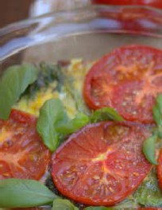

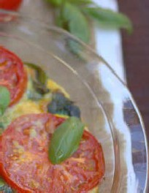
Break”Fasts”

Eggs Florentine Casserole



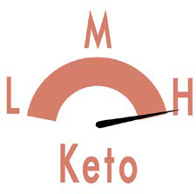
Prep Time: 5 minutes Cook Time: 25-45 minutes Servings: 4
1 pound ground pork
- tablespoon paleo fat or butter for frying 1/4 cup onion diced
- cloves garlic minced or 2 teaspoons
2 1/2 teaspoons sea salt fine grain, divided 2 teaspoons fresh ground black pepper
divided
1 cup spinach or other greens 1 cup basil leaves whole leaves 1 slice tomato ¼ inch thick
8 eggs
basil leaves garnish with this additional ingredient
- Preheat oven to 350 degrees F. Place the pork in a cast iron skillet and sauté in 1 tablespoon paleo fat while crumbling. Sauté until cooked through, about 5 minutes. Add the onion and garlic, sauté another 2 minutes. Add 1 ½ teaspoon salt and 1 teaspoon pepper.
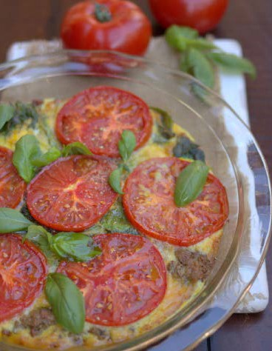
- Place the ground pork mixture into the bottom of a 9 inch pie pan. Crack 8 eggs into a dish and whisk until well combined. Add 1 teaspoon salt and pepper. Add the spinach and 1 cup basil to the eggs. Pour egg mixture over the pork into the pie pan. Slice the tomato into ¼ inch thick slices and top the eggs with the tomato. Place in oven to bake for 30-35 minutes or until eggs are set in the middle. Garnish with basil leaves.

Nutritional Info (per serving)
Calories 491 | Fat 38g 71% | Protein 32g 26% | Carbs 4g 3% | Fiber 1g

Pizza Deviled Eggs

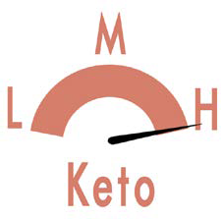
Prep Time: 5 minutes Cook Time: 11 minutes Servings: 4

12 large eggs
- cup mayonnaise (paleo or homemade) 1 teaspoon pizza sauce
- teaspoons italian seasoning plus extra for garnish
1/2 teaspoon crushed red pepper flakes plus extra for garnish
GARNISH:
Pepperoni mini (omit for vegetarian)

BUSY FAMILY TIP: I keep a
dozen hard-boiled eggs in my fridge at all times. My boys who are four and six love to help me in the kitchen and peeling eggs is one of the things they can do without my constant attention so I can prepare other food.
- Place eggs in a large saucepan and cover with cold water. Bring the water to a boil, then immediately cover the pan and remove it from the heat. Allow the eggs to cook in hot water for 11 minutes.
- After 11 minutes, drain the hot water and rinse with very cold water for about a minute or two to stop the cooking process. Peel the boiled eggs and cut them in half lengthwise. Remove the yolks and place them in food processor. Blend the egg yolks until they are the texture of very fine crumbles. Add the mayonnaise, pizza sauce, Italian seasoning, red pepper flakes and salt, puree until smooth. Fill the egg white halves with the yolk mixture. Garnish each egg with mini pepperonis, Italian seasoning and red pepper flakes.
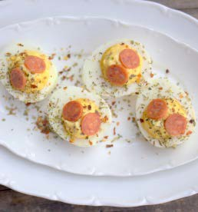
- Keep leftover deviled eggs in an airtight container in the fridge for 3 days.

Nutritional Info (per serving)
Calories 642 | Fat 61g 86% | Protein 19g 12% | Carbs 3g 2% | Fiber 0g

Open Faced Breakfast Sandwich

Prep Time: 10 minutes Cook Time: 20 minutes Servings: 1

2 medium Portobello mushrooms stems removed and chopped
sea salt and pepper to taste fine grain 2 slices bacon
2 large eggs fried TOPPINGS:
2 tablespoons hollandaise dairy-free (recipe on page 19)
- Heat oven to 400° F. Lightly grease medium baking dish; place mushroom caps in dish, gill-side down. Season with salt and pepper.
- Bake mushroom caps 15-20 mins or until tender but not limp, turning once.
- Place the bacon in a skillet and fry until crispy. Remove from pan and fry 2 eggs in the bacon grease. Season with a touch of salt and pepper. Once the whites are set and the yolks are runny, remove from skillet.
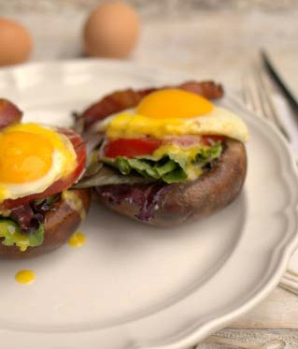
- Place mushroom caps gill side up on plates; top with greens, a slice of tomato, fried egg, bacon and drizzle with hollandaise.

Nutritional Info (per serving)
Calories 509 | Fat 45g 80% | Protein 24g 19% | Carbs 2g 1% | Fiber 0 4g

Gyro Breakfast Patties

Prep Time: 8 minutes Cook Time: 5 minutes Servings: 12

2 1/2 pounds bulk ground lamb sausage (or beef)
1/2 pound ground pork fat 1/4 cup red onion diced
2 teaspoons sea salt
2 teaspoons fresh ground black pepper 1 teaspoon ground dried oregano
1 teaspoon garlic minced
lard or coconut oil, for the pan
Keto dipping sauce of choice optional

BUSY FAMILY TIP: Make a
double batch of this recipe and store the cooked patties in the fridge or freezer for easy breakfasts on the go. Cooked patties will keep in the fridge for 5 days and in the freezer for 6 months.
  - Place the ground lamb, ground pork fat, onion, garlic, salt and spices in a large bowl. Mix well to evenly combine all the in- gredients.
  - Using your hands, form into twelve 3-inch-round patties.
  - To cook, heat 1 tablespoon of lard or coconut oil in a large pan over medium heat. Sauté for 3 to 5 minutes per side or until cooked through.
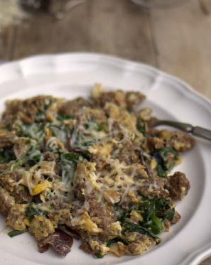
  - Serve with the keto dipping sauce of your choice, if desired.

Nutritional Info (per serving)
Calories 345 | Fat 26g 68% | Protein 26g 30% | Carbs 1g 2% | Fiber 0 3g

Dairy Free & Nut Free Pancakes

Prep Time: 4 minutes Cook Time: 4 minutes Servings: 2

2 large eggs hard boiled and peeled 2 large eggs
2 tablespoons Confectioners Swerve (or a few drops of stevia glycerite or flavored stevia such as vanilla/english toffee)
1 teaspoon cinnamon
1 teaspoon vanilla extract
1/4 teaspoon sea salt fine grain 1/4 teaspoon baking powder coconut oil for frying
- Place all the ingredients, except the coconut oil in a blender and combine until very smooth.
- Heat a 1/2 tablespoon of coconut oil on a “healthified” non-stick pan to medium heat. Once hot, pour 1/4 the batter onto the skillet at a time. Fry until golden brown, about 2 minutes, then flip and cook until done. Remove from skillet and repeat with remaining coconut oil and batter.
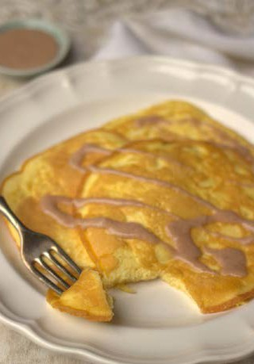
- Serve with Dairy Free Cinnamon Syrup (recipe on page 27)

Nutritional Info (per serving)
Calories 172 | Fat 12g 63% | Protein 13g 30% | Carbs 3g 7% | Fiber 1g

Chocolate French Toast

Prep Time: 5 minutes Cook Time: x minutes Servings: 7 (2 slices per)

1 batch Chocolate Angel Food Cake sliced (recipe on page 64)
5 large eggs
1 cup unsweetened almond milk cashew (or hemp milk if nut free)
1/2 teaspoon sea salt fine grain coconut oil for frying
- Cut the cake into 1 inch thick slices. In a medium bowl, mix the eggs and almond milk and the salt.
- Heat a skillet to medium-high heat, greased with coconut oil. Dip each slice of angel food cake into the egg mixture.
- Place on skillet and fry on each side until golden brown. Driz- zle with my homemade Keto Syrup (recipe on page 27) or my Chocolate Sauce (recipe on page 26).

Nutritional Info (per serving)
Calories 232 | Fat 12g 47% | Protein 25g 43% | Carbs 6g 10% | Fiber 2g
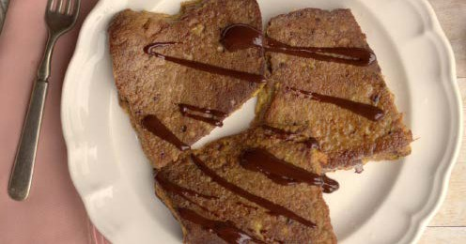

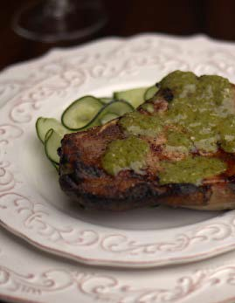

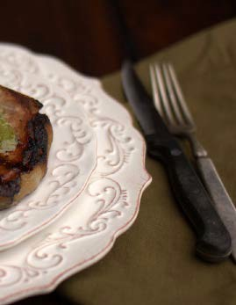

Sauces and
Condiments

Green Goddess Dressing

Prep Time: 5 minutes Cook Time: 0 minutes Servings: 4

1/3 cup mayonnaise store-bought or homemade
1 tablespoon coconut vinegar
- tablespoon chives and/or scallions, finely chopped
1/2 teaspoon anchovy paste (about 1/3 of an anchovy), or 1/4 teaspoon coarse salt for vegetarian
- teaspoons lemon juice
1/8 teaspoon fresh ground black pepper 1/4 teaspoon garlic minced
1-2 tablespoons chicken bone broth homemade or boxed chicken broth to thin the dressing (or veggie broth)
- Meanwhile make the sauce. Place all the ingredients except the broth in a blender or large bowl and combine until smooth.
- Add just enough broth to thin to the desired consistency. Store in an airtight container in the refrigerator for up to 1 week. Shake well before using.

Nutritional Info (per serving)
Calories 139 | Fat 15g 98% | Protein 0 2g  1% | Carbs 0 3g  1% | Fiber 0 1g

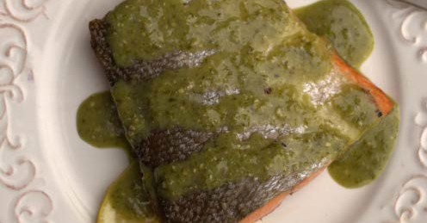

Dairy Free Hollandaise

Prep Time: 3 minutes Cook Time: 5 minutes Servings: 4

- egg yolks
2 tablespoons lemon juice
1 tablespoon Dijon mustard
3/4 cups unsalted butter melted organic or melted bacon fat or duck fat if dairy sensitive
1/2 tsp sea salt
1/8 tsp fresh ground black pepper
- Make hollandaise sauce: In the bottom of a double boiler or in a medium saucepan, bring 1 in. of water to a simmer over high heat and adjust heat to maintain simmer. Put egg yolks, lemon juice, and mustard in top of a double boiler or in a round-bot- tomed medium bowl and set over simmering water. Whisk yolk mixture to blend.
- Whisking constantly, add butter in a slow, steady stream (it should take about 90 seconds). Cook sauce, whisking, until it reaches 140°, then adjust heat to maintain temperature (remove from simmering water if necessary). Add salt, pepper, and cay- enne and continue whisking until thick, about 3 minutes. Adjust seasonings to taste. Remove from stove and set aside.

Nutritional Info (per serving)
Calories 321 | Fat 35g 98% | Protein 0 1g  1% | Carbs 0 1g  1% | Fiber 0g
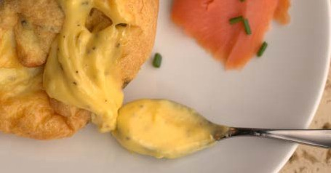

Keto Tortilla Wraps

Prep Time: 4 minutes Cook Time: 4 minutes Servings: 2

2 large eggs
2 large hard boiled eggs 1/2 teaspoon sea salt
2 tablespoons green onions
OPTIONAL: fresh chopped Herbs of choice. Cilantro, green onion, etc.
1/2 tablespoon coconut oil
- Place the eggs, peeled hard boiled eggs, salt and herbs in a blend- er and combine until very smooth and there are no lumps.
- Heat a crepe pan or non-stick pan with the oil to medium-low heat.
- While that is heating scramble the eggs with salt and any herbs you prefer in a small bowl until well combined.
- Once the pan is hot. Add the eggs and whirl the pan to spread the eggs into a very large and thin crepe. Let the eggs set for 3-4 minutes or until cooked through.
- Remove wrap from the pan, sliding it onto a plate to cool. Once cool, drizzle with keto dressing of your choice (drizzling is easier than spreading, which often breaks the wrap).
- Fill with lettuce and fillings of your choice. Wrap up like a tor- tilla and enjoy! Store extras in an airtight container in the fridge for up to 3 days.

Nutritional Info (per serving)
Calories 172 | Fat 13g 68% | Protein 13g 30% | Carbs 1g 2% | Fiber 0 5g
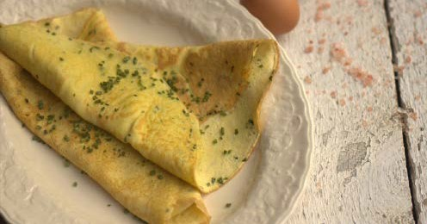

Red Chile Sauce

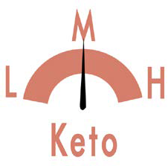
Prep Time: x minutes Cook Time: x minutes Servings: 4
1 To the blender, add the red fresno peppers, habaneros, juice of 2 key limes, oil and salt to taste. Pulse or blend until desired consistency. Taste for salt.

4 red fresno peppers stems removed
2 to 3 habanero peppers stems removed 2 key limes juice
2 tablespoons MCT oil or any mild tasting oil
sea salt and pepper to taste to taste

Nutritional Info (per serving)
Calories 76 | Fat 5g 59% | Protein 5g  5% | Carbs 7g 36% | Fiber 2g
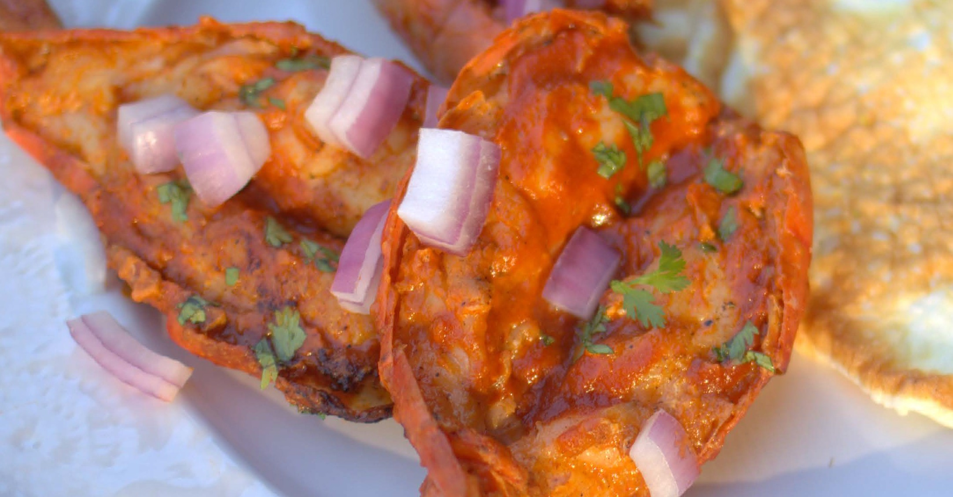

RED CURRY DIPPING SAUCE

Prep Time: 5 minutes Cook Time: 15 minutes Servings: 6
1 Make the dipping sauce by placing all the ingredients in a small saucepan and heat on medium-high for 15 minutes or until sauce has thickened a bit. Remove from heat and set aside.

2/3 cup coconut milk
- teaspoon Thai red curry paste
1/3 cup chicken bone broth or chicken stock (homemade or boxed will work)
- tablespoons cilantro leaves and stems fresh 1 tablespoon basil leaves fresh
1 tablespoon fish sauce
1 teaspoon garlic minced; or one clove minced
1 teaspoon fresh ginger finely chopped 1 tablespoon lemon juice or lime
Nutritional Info (per serving)
Calories 50 | Fat 4g 78% | Protein 1g 11% | Carbs 1g 11% | Fiber 0 3g

1/4 teaspoon sea salt
1/2 teaspoon fresh ground black pepper 1/2 teaspoon stevia glycerite (optional
sweetness)
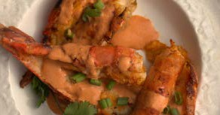

Cilantro Lime Sauce

Prep Time: 5 minutes Cook Time: 0 minutes Servings: 6
1 Placing all the sauce ingredients in a food processor and puree until very smooth. Store in an airtight container in the refriger- ator for up to 1 week. Shake well before using.

- cup mayonnaise (or sour cream if not dairy-sensitive and/or egg-free)
1/4 cup fresh cilantro finely chopped 1/4 cup lime juice
- tablespoons fresh ginger grated
2 tablespoons chives chopped, fresh 1 teaspoon garlic finely chopped
1 jalapeño peppers seeded and coarsely chopped
1/2 teaspoon sea salt
Nutritional Info (per serving)
Calories 286 | Fat 31g 97% | Protein 0 3g  1% | Carbs 2g 2% | Fiber 0 2g

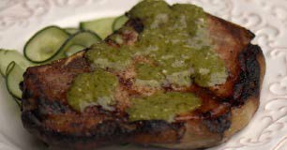

Dairy Free Ranch Dressing

Prep Time: x minutes Cook Time: x minutes Servings: x

1 cup organic mayo
3/4 cup beef bone broth or chicken/veggie broth, boxed will work
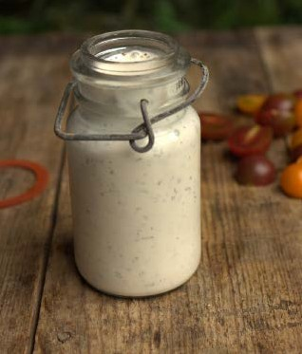
1/2 teaspoon dried chives 1/2 teaspoon dried parsley 1/2 teaspoon dried dill weed 1/4 teaspoon garlic powder 1/4 teaspoon onion powder 1/8 teaspoon sea salt
1/8 teaspoon fresh ground black pepper
- Place all the ingredients a large jar and shake vigorously until well combined.
- Cover and refrigerate for 2 hours before serving (it will thicken up as it rests).

Nutritional Info (per serving)
Calories 145 | Fat 16g 98% | Protein 0 3g  1% | Carbs 0 5g  1% | Fiber 0 2g

Buffalo Wing Sauce

Prep Time: 5 minutes Cook Time: 5 minutes Servings: 8

2/3 cup hot pepper sauce no sugar
1/2 cup coconut oil or butter if not dairy sensitive
1 1/2 tablespoons coconut vinegar or apple cider vinegar
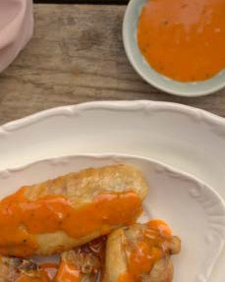
1/4 teaspoon cayenne pepper 1/8 teaspoon garlic powder sea salt to taste
- Combine the hot sauce, oil, vinegar, cayenne pepper, garlic pow- der, and salt in a pot and place over medium heat. Bring to a simmer while stirring with a whisk. As soon as the liquid begins to bubble on the sides of the pot, remove from heat, stir with the whisk, and set aside for use.

Nutritional Info (per serving)
Calories 126 | Fat 14g 100% | Protein 0g  0% | Carbs 0 1g  0% | Fiber 0g

Dairy Free Chocolate Drizzle

Prep Time: 2 minutes Cook Time: 5 minutes Servings: 8

- ounces unsweetened baking chocolate chopped fine
2 tablespoons coconut oil 3/4 cup coconut milk full-fat 1 cup Confectioners Swerve 1 teaspoon stevia glycerite 1/4 teaspoon sea salt
1 teaspoon vanilla bean split lengthwise and seeds scraped, or 1vanilla extract, about 6 inches long
1/2 teaspoon almond extract
- In a medium-sized saucepan or double boiler, melt the chocolate and coconut oil until the mixture is melted and smooth over medium-low heat. Stir in the coconut milk, natural sweetener, stevia, and salt. Continue to cook, stirring constantly, until it begins to boil, then remove the pan from the heat and add the vanilla bean seeds and almond extract. It will thicken as it cools.
- Once cooled, transfer to a jar. Seal and store in the fridge for up to 2 weeks.

Nutritional Info (per serving)
Calories 108 | Fat 10g 85% | Protein 1g  5% | Carbs 3g 10% | Fiber 2g

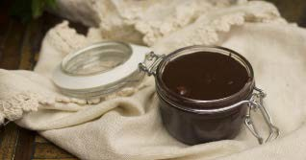

Dairy Free Cinnamon Syrup



Prep Time: x minutes Cook Time: x minutes Servings: x
1 Place all the ingredients in a heat-safe bowl and heat until coco- nut oil is melted. Stir well and use over pancakes. If it hardens, reheat until liquid.

1/2 cup coconut oil liquid 1/4 cup Confectioners Swerve
1-2 teaspoons ground cinnamon
1 teaspoon maple extract or vanilla extract sea salt a pinch

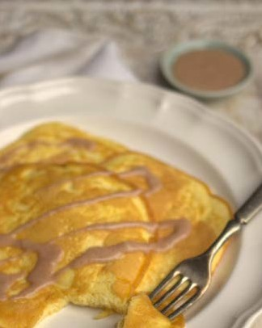
Nutritional Info (per serving)
Calories 127 | Fat 14g 99% | Protein 0g  0% | Carbs 0 4g  1% | Fiber 0 2g

Keto Egg Bread

Prep Time: 10 minutes Cook Time: 30 minutes Servings: 10

6 large eggs separated
1/4 cup Jay Robb unflavored egg white protein powder or whey protein
4 ounce cream cheese room temperature (omit for dairy free and fold in reserved yolks instead)
1/2 teaspoon onion powder optional
- Preheat the oven to 325 degrees F. Separate the eggs (save the yolks), and whip the whites for a few minutes until VERY stiff (I use a stand mixer on high for a few minutes).
- Gently mix the protein powder into the whites. Then slowly fold the softened cream cheese (or reserved egg yolks) into the whites (making sure the whites don’t fall).
- Grease a baking sheet and fill with “dough.”
- FOR BUNS: greese a baking sheet and make little mounds in bun shapes with the “dough”.
- Bake for 25-35 minutes or until golden brown (if bread comes out dry, cook for closer to 20 minutes).
- Let completely cool before cutting or the bread will fall. Cut into 12 slices. I keep this bread in the freezer at all times to make sandwiches. OPTION: Make bread into 10-12 buns on a greased cookie sheet.

Nutritional Info (per serving)
Calories 50 | Fat 3g 53% | Protein 6g 47% | Carbs 0g 0% | Fiber 0g

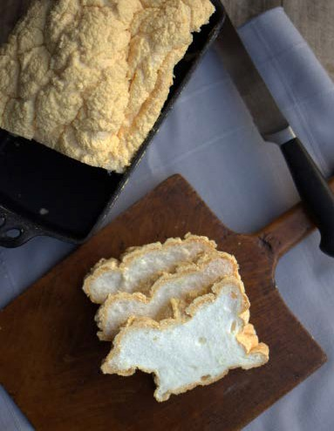

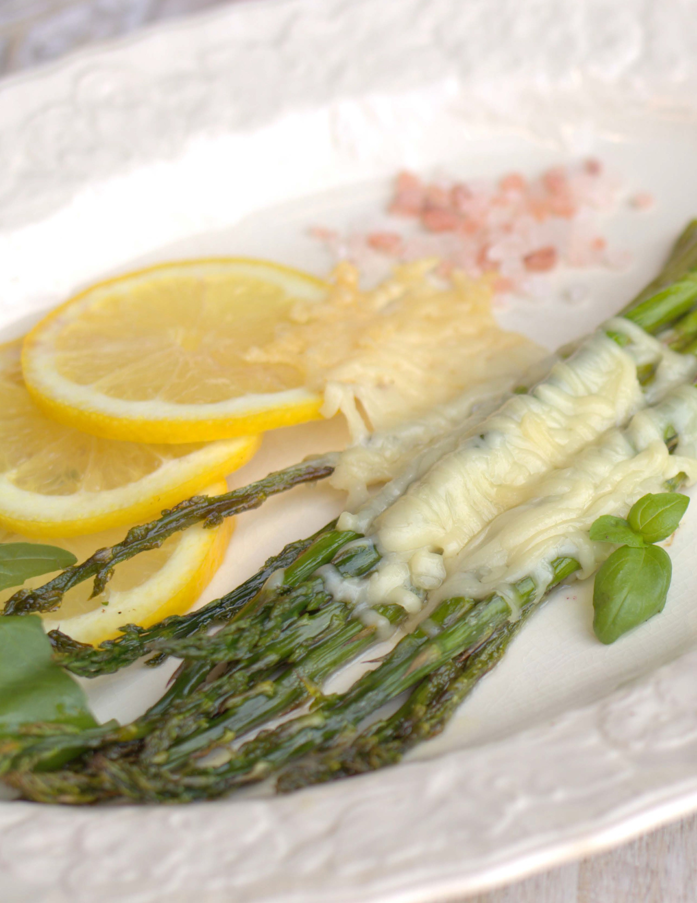

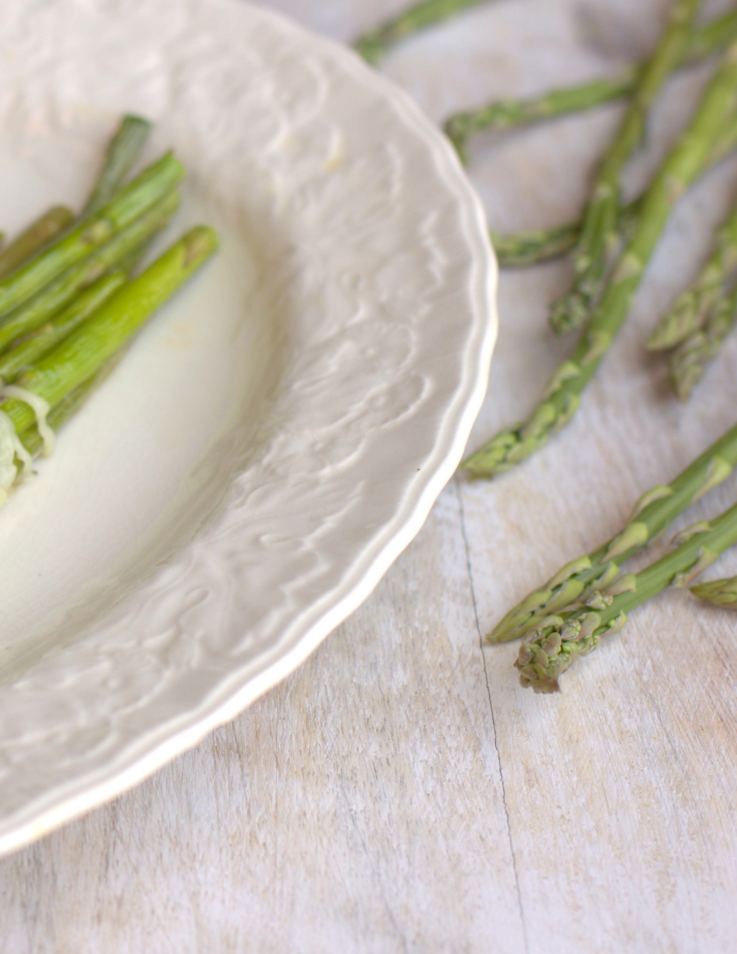

Side
Dishes

Parmesan Basil Asparagus

Prep Time: 4 minutes Cook Time: 10-20 minutes Servings: 4

- pound asparagus trimmed
- tablespoons paleo fat melted lard, tallow or coconut oil
5 cloves garlic minced 4 slices lemon
2 tablespoons basil leaves chopped 1/2 teaspoon sea salt fine grain
1/4 teaspoon fresh ground black pepper 1 cup Parmesan cheese grated
- Preheat oven to 400 degrees F. Trim the asparagus and discard the woody stems. Coat the asparagus with melted fat. Place on a cookie sheet with edges in one layer. Season with salt and pepper.
- Top asparagus with garlic, lemon slices and basil. Roast for 10 minutes for thin asparagus, 20 for medium to thick stalks, or until slightly chard on the ends. Remove from oven and place Parmesan on the asparagus. Place back in oven for 30-60 sec- onds, or until cheese is melted.
- Remove from oven and serve. Best served fresh.

Nutritional Info (per serving)
Calories 360 | Fat 26g 65% | Protein 26g 29% | Carbs 6g 6% | Fiber 3g
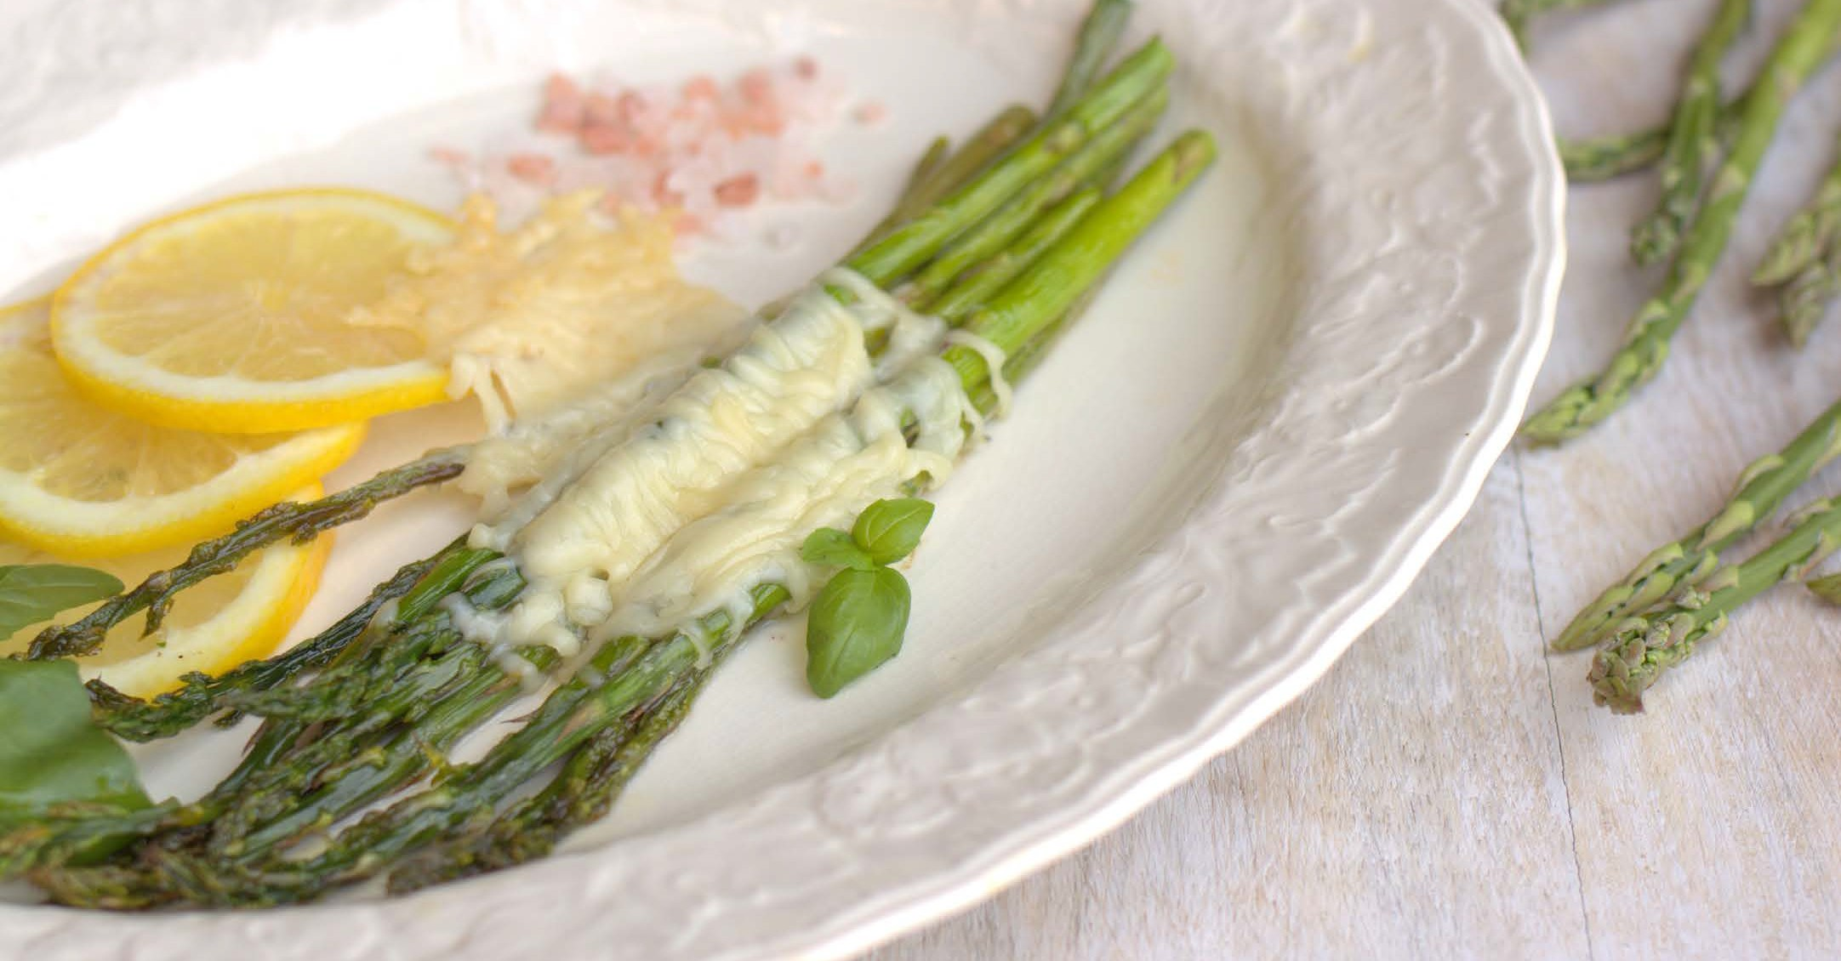

Buffalo Chicken Wings

Prep Time: 5 minutes Cook Time: 35 minutes Servings: 6
2 pounds chicken wings and drummies 3 tablespoons butter melted (or melted
coconut oil if dairy free) 1 teaspoon sea salt fine grain
1/2 teaspoon fresh ground black pepper
6 servings buffalo wing sauce (recipe on page 25)
  - Preheat oven to 400 degrees F.
  - Place wings in a large bowl. Add the oil and toss to get the oil all over the wings.
  - Place the chicken wings on a baking sheet with edges.
  - Season the wings liberally with salt and pepper.
  - Place in oven for 35-40 minutes or until wings are crispy on the edges and cooked through.
  - Remove from oven and brush on buffalo wind sauce. Serve extra on the side!

Nutritional Info (per serving)
Calories 485 | Fat 36g 67% | Protein 40g 33% | Carbs 0 3g  1% | Fiber 0 1g
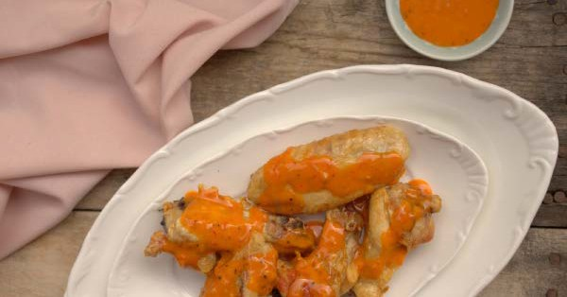

Halibut Red Curry

Prep Time: 5 minutes Cook Time: 25-45 minutes Servings: 4

1 tablespoon MCT oil or expeller pressed extra virgin olive oil
3 shallots diced
1 1/2 tablespoons Thai red curry paste 1 1/2 cups chicken bone broth
14 ounces coconut milk in can 16 ounces halibut fillets
1/4 cup fresh cilantro
1/4 cup green onions sliced into ½ inch pieces
1 lime juice
- Place 1 tablespoon MCT oil in a cast iron skillet and heat to medium.
- Add the shallots and sauté until tender, about 2 minutes. Reduce heat to low. Whisk in the curry paste, broth and coconut milk. Simmer on low, uncovered for 20-40 minutes or until broth reduces a bit. The longer you simmer, the thicker your sauce will be. Place the halibut fillets into the broth and poach for 10 minutes or until cooked through, timing will depend on how thick your fillets are.
- Stir in chopped cilantro, green onions and squeeze in juice from 1 lime and stir. Immediately remove from heat and place in serv- ing bowls. Garnish with additional sliced green onion, cilantro leaves.
Nutritional Info (per serving)
Calories 333 | Fat 21g 58% | Protein 27g 33% | Carbs 8g 9% | Fiber 1g

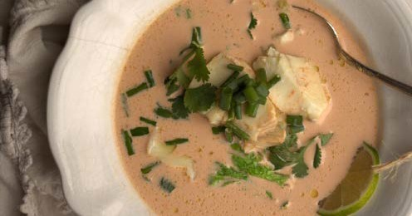

Asparagus Cobb Salad

Prep Time: 4 minutes Cook Time: 10-20 minutes Servings: 4

  - pound asparagus trimmed
  - tablespoons paleo fat melted lard, tallow or coconut oil
5 cloves garlic minced
2 tablespoons chives chopped fresh plus extra for garnish
1/2 teaspoon sea salt fine grain
1/4 teaspoon fresh ground black pepper TOPPING:
- cup ham diced
- hard boiled eggs diced and seasoned with salt
4 tablespoons Dairy-Free Ranch Dressing (recipe on page 24)
- Preheat oven to 400 degrees F. Trim the asparagus and discard the woody stems.
- Coat the asparagus with melted fat. Place on a cookie sheet with edges in one layer.
- Season with salt and pepper.
- Top asparagus with garlic and chives. Roast for 10 minutes for thin asparagus, 20 for medium to thick stalks, or until slightly chard on the ends.
- Meanwhile chop the ham and hard boiled eggs. Make the ranch dressing.
- Remove from oven.
- Top with diced ham, chopped hard boiled eggs, Ranch dressing and additional chives. Best served fresh.

Nutritional Info (per serving)
Calories 335 | Fat 26g 70% | Protein 19g 23% | Carbs 6g 7% | Fiber 2g

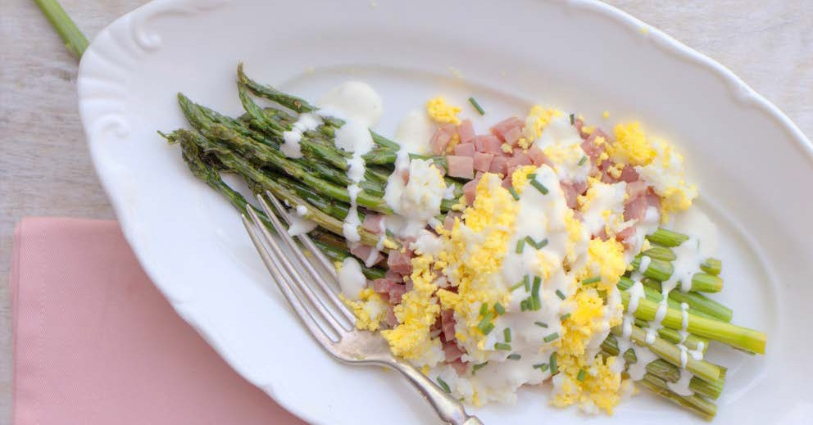

CREAMY CHICKEN SOUP

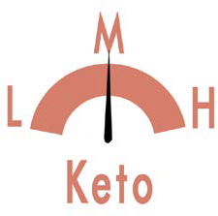
Prep Time: 8 minutes Cook Time: 8 minutes Servings: 6

2 avocado ripe and peeled
1 jalapeño peppers seeds and ribs removed 1 tablespoon lime juice
1/4 teaspoon cayenne pepper
4 cups chicken bone broth or homemade bone broth for thicker soup
1 1/2 teaspoons sea salt
1/4 teaspoon fresh ground black pepper
3 tablespoons coconut oil or rendered paleo fat
1/2 cup onion chopped 1 clove garlic
1 pound chicken thighs boneless, skinless, cut into 1 inch pieces
- Garnish with diced bacon and chives if desired. Place the avo- cados, jalapeno, lime juice, cayenne, broth, salt and pepper in a blender or food processor and puree until smooth.
- Heat the oil in the cast iron skillet over medium heat. Add the onion and garlic. Sauté until onion is translucent, about 5 min- utes. Add the chicken pieces and sauté until cooked through, about 4 minutes. Add the avocado puree and heat until soup is warm, about 2 minutes. Serve the soup topped with diced bacon and chives if desired.

Nutritional Info (per serving)
Calories 362 | Fat 28g 69% | Protein 22g 24% | Carbs 8g 8% | Fiber 8g

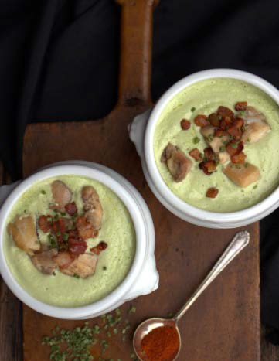

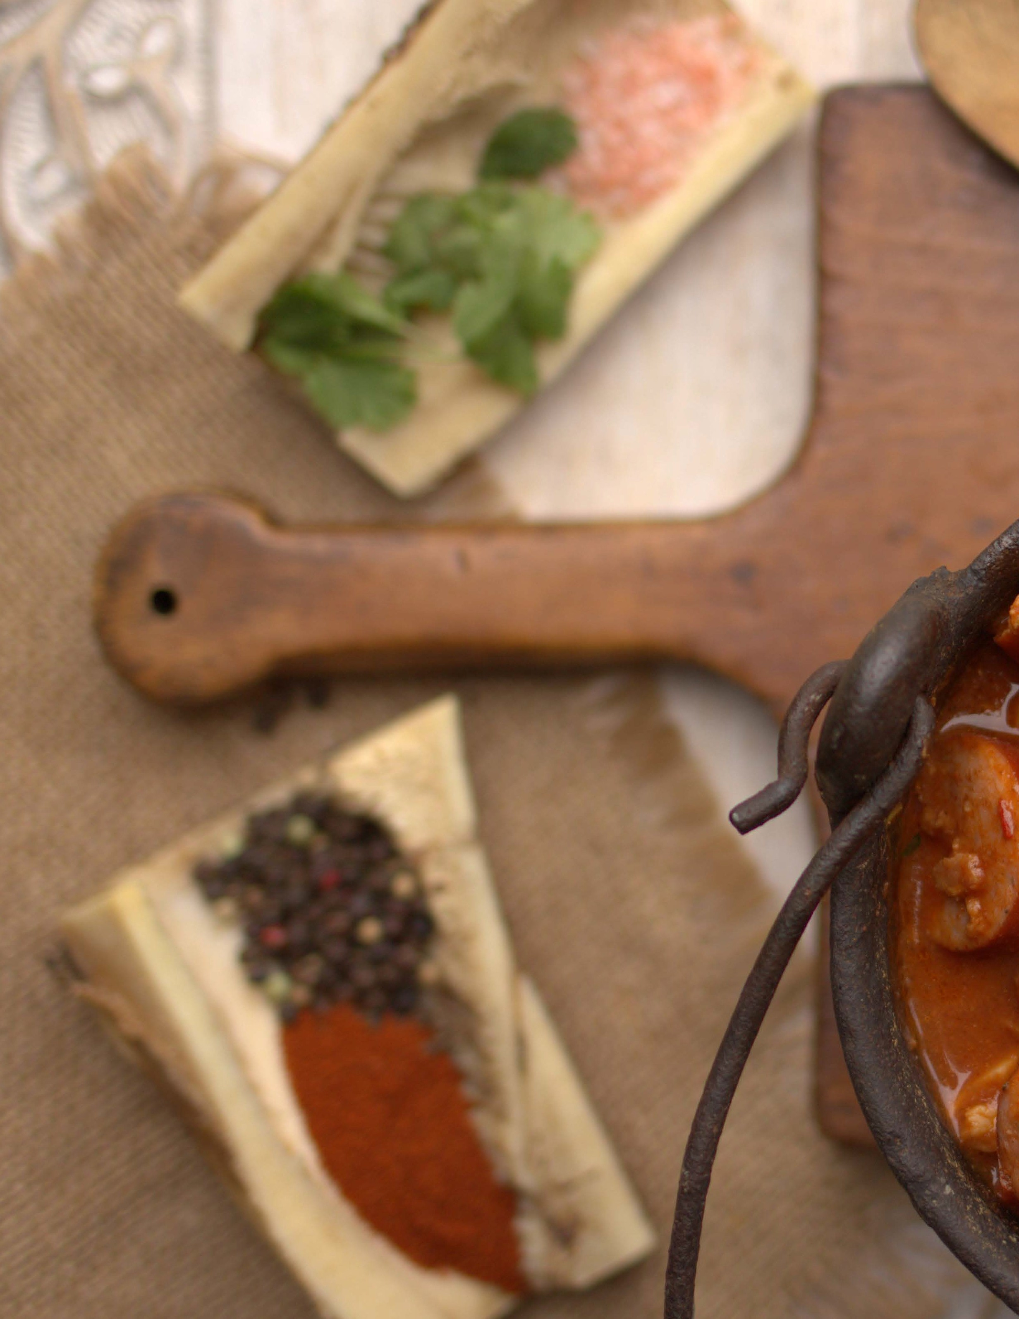

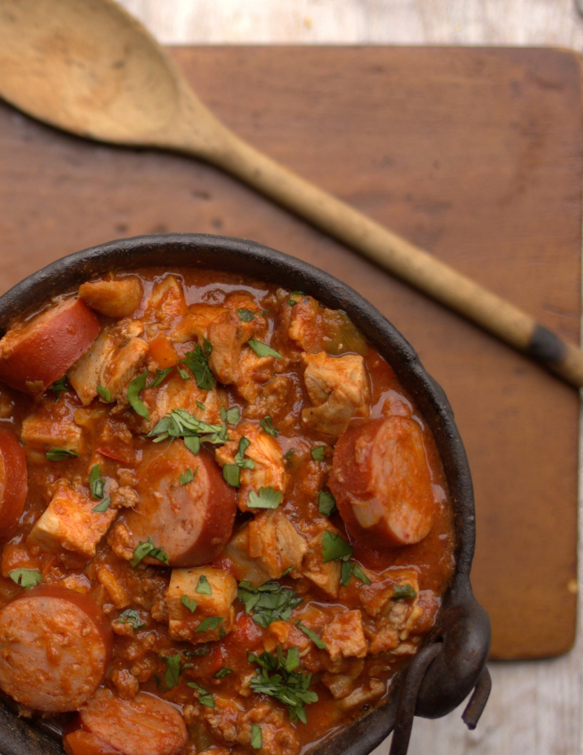
Main
Dishes

Salmon with Crispy Skin

Prep Time: 8 minutes Cook Time: 15 minutes Servings: 4

24 ounces salmon fillets wild caught
- sea salt and pepper to taste
- tablespoons MCT oil or quality olive oil (melted butter if not dairy sensitive)
1 batch Green Goddess Dressing (recipe on page 18)
- Preheat oven to broil. Season the salmon well on both sides with salt and pepper. Place skin side up on a sheet pan with edges. Drizzle with oil or butter. Place in oven for 5-7 minutes (depend- ing on how thick your fillets are).
- Remove fillets from oven and serve skin side up to prevent sog- giness. Serve 2 tablespoons sauce over each fillet.

Nutritional Info (per serving)
Calories 385 | Fat 28g 65% | Protein 33g 34% | Carbs 0 3g  1% | Fiber 0 1g
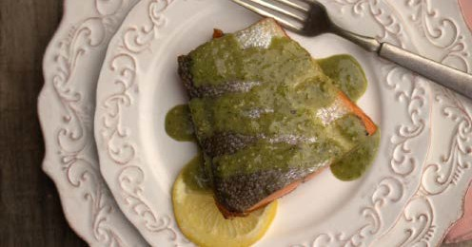

Crab Claw Curry “ Rice”

Prep Time: 4 minutes Cook Time: 18 minutes Servings: 4

2 pounds snow or king crab clusters thawed if frozen
8 large eggs
- 1/3 cups coconut milk
- 1/2 teaspoons curry powder or curry spice
1 1/8 teaspoon sea salt fine
1/4 teaspoon fresh ginger grated (I keep a ginger root in the freezer)
1/4 cup coconut oil or butter (if not dairy sensitive)
4 lime wedges for serving (optional) fresh cilantro and green onion
  - Cut an incision, lengthwise, into the shell of each crab leg.
  - Heat salted water in a pot over medium heat.
  - Add the crab legs to the pan and allow them to simmer in the water until completely heated, 5 to 6 minutes.
  - Meanwhile make the “rice.” Place the eggs, coconut milk, curry, salt and ginger in a bowl and scramble until well combined.
  - In a large saucepan, melt the paleo fat/butter over medium heat. Add the egg mixture to the pan and cook until the mixture thickens and small curds form, all the while scraping the bot- tom of the pan and stirring to keep large curds from forming. (A whisk works well for this.) This will take about 7 minutes.
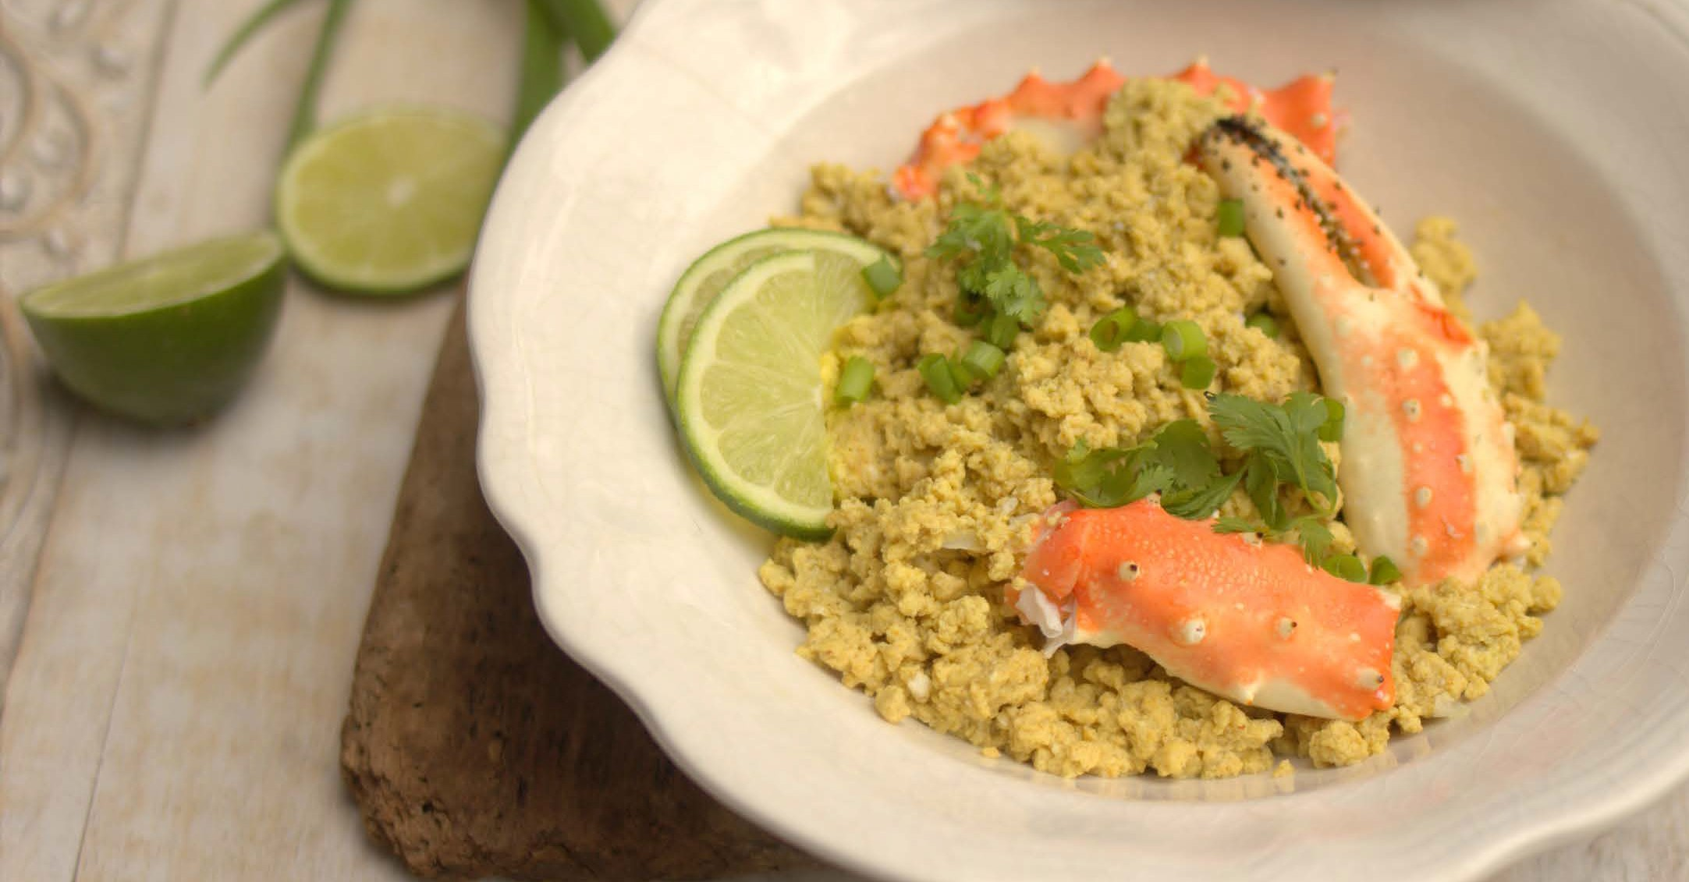
  - Place the curry “rice” on a serving platter and top with crab claw pieces. Serve with lime wedges, if desired.

Nutritional Info (per serving)
Calories 615 | Fat 38g 56% | Protein 67g 44% | Carbs 2g 1% | Fiber 0 1g

Main Dishes - 37

Kentucky Hot Brown

Prep Time: 8 minutes Cook Time: 10 minutes Servings: 12

For the cheese sauce:
1 cup unsalted butter
1 cup Beef broth or water or chicken broth 2 ounces cream cheese
1 pound sharp cheddar cheese extra, shredded
1/2 teaspoon sea salt
For the egg bread:
4 large eggs
1/4 cup unsweetened almond milk 1/8 teaspoon sea salt fine grain
12 slices keto bread (1/2-inch thick cut) 4 tablespoons butter
4 tablespoons coconut oil
For assembly:
keto bread Egg battered
24 slices turkey roasted breast, sliced into 1/8-inch thick slices
3 ripe tomatoes beefsteak, cut into 1/2- inch thick slices and griddled until slightly charred and just cooked through
1 1/2 cups sharp cheddar cheese grated 1/2 cup Parmesan cheese freshly grated
16 thick slices bacon slab, diced and cooked until crisp
chives Finely chopped fresh
fresh flat-leaf parsley Finely chopped
- Sauce: To make the cheese sauce, place the butter in a large saucepan and heat on high for about 5 minutes. Whisk while heating.
- The butter will start to sizzle and fluff up. Watch for brown flecks (not black!) and remove from heat.
- Slowly add the organic broth, cream cheese and shredded cheese. Add salt to taste.
- Heat lightly just until cheese is pretty much melted.
- Remove from heat and place in a blender to combine until very very smooth. Use for sandwiches.
- For the egg bread: Whisk together the eggs, almond milk and salt in a medium bowl. Dip each slice of bread in the mixture.
- Heat 2 tablespoons of butter and 2 tablespoons of oil in a large “healthified” non-stick saute pan over medium-high heat. Cook 4 slices of the bread at a time until golden brown on both sides. Remove and place on a baking sheet. Repeat with the remaining bread.
- For assembly: Preheat broiler. Place the egg bread on a baking sheet, place under the broiler and heat on both sides for 20 sec- onds just to warm through.
- Top each slice of bread with 2 to 3 slices of turkey and 2 slices of tomato, ladle sauce over the top and divide the cheddar cheese and Parmesan over the top of each slice.
- Place under the broiler and cook until bubbly and the top is golden brown. Remove from the oven, top each slice with diced bacon bits and sprinkle each slice with chives and parsley.

Nutritional Info (per serving)
Calories 720 | Fat 63g 79% | Protein 35g 19% | Carbs 3g 2% | Fiber 0 1g

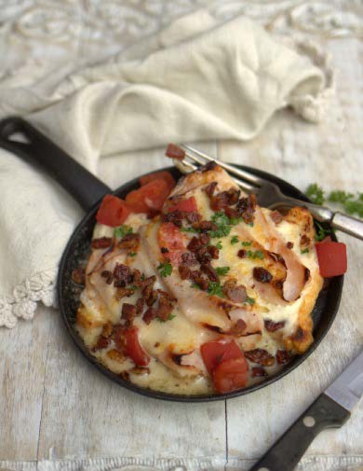

Camaron en Chile Rojo

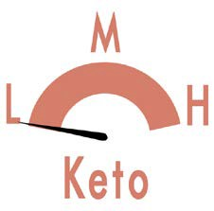
(Shrimp in Red Chile)

Prep Time: 2 minutes Cook Time: 7 minutes Servings: 6

16 large shrimp cleaned 4 key limes juice
Sauce:
4 red fresno peppers stems removed
2 to 3 habanero peppers stems removed 2 key limes juice
2 tablespoons MCT oil or any mild tasting oil
sea salt and pepper to taste to taste 1/2 cup red onion thinly sliced
2 tablespoons fresh cilantro chopped
- Peel and clean the shrimp. Using a small, sharp knife, butterfly the shrimp open by slicing almost all the way through the back side. Take the knife and carefully slice into where the shrimp curves in before the tail part on the inside. This will help the shrimp lay more flat while marinating and cooking.
Nutritional Info (per serving)
Calories 299 | Fat 18g 54% | Protein 22g 30% | Carbs 12g 16% | Fiber 3g

- Rinse the shrimp in cold water and pat dry with paper towels and transfer back to shallow glass dish. To the shrimp, add the juice of the 8 key limes, making sure the shrimp is covered with lime juice. Cover and chill while you prep the rest of ingredients.
- To the blender, add the red fresno peppers, habaneros, juice of 2 key limes, oil and salt to taste. Pulse or blend until desired consistency. Taste for salt.
- Layer the onions over the top of the shrimp. Add cilantro, cover and chill for just 15 more minutes. The shrimp will be ready to eat after only 30 minutes, but you could leave it in until you are ready to eat. Before serving, remove shrimp from key lime marinade (discard lime marinade) and mix together with sauce. Season with fresh cracked pepper. Serve with keto tortillas. Yields 4 servings.

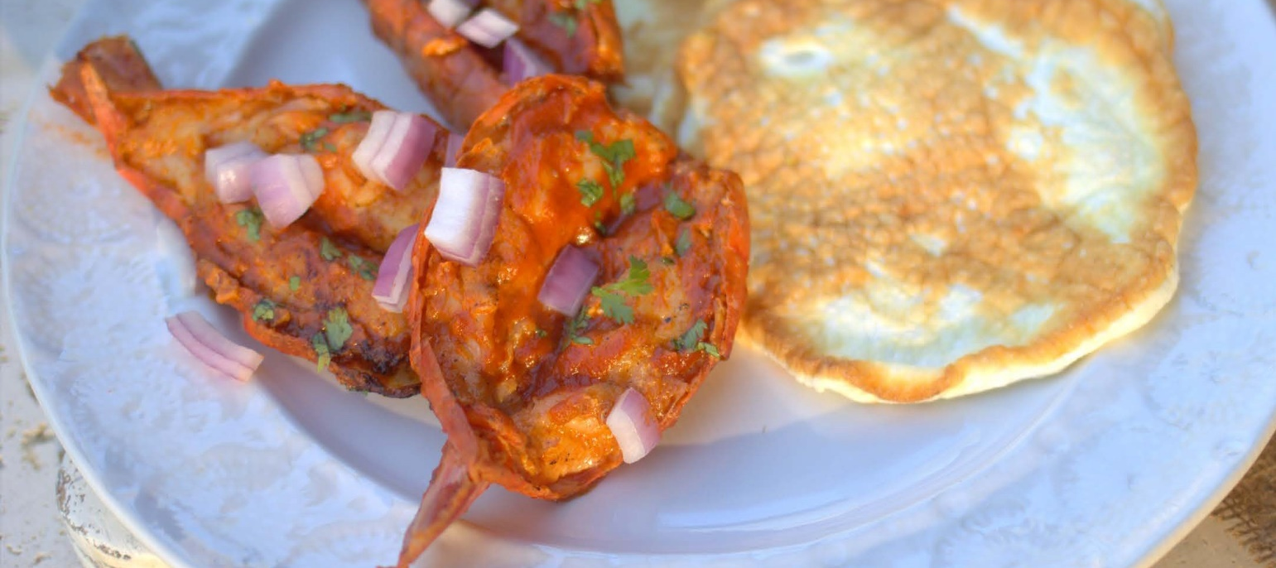

Shrimp Arrabbiata

Prep Time: 5 minutes Cook Time: 5 minutes Servings: 4

2 packages Miracle Noodles (or 4 cups zucchini noodles)
2 tablespoons coconut oil divided
- pound shrimp large, peeled and deveined
1/4 teaspoon sea salt fine grain 1/2 cup yellow onion diced
- teaspoons garlic bottled, minced 1/2 teaspoon dried basil
1/2 teaspoon crushed red pepper flakes 2 tablespoons tomato paste
14.5 ounces diced tomatoes in can, undrained
  - Drain and rinse Miracle Noodles well. Set aside.
  - Heat 1 tablespoon oil in a large nonstick skillet over medi- um-high heat. Sprinkle shrimp with salt; add shrimp to pan. Cook 2 minutes on each side or until shrimp are done. Transfer shrimp to a bowl. Heat remaining 1 tablespoon oil in pan. Add onion, minced garlic, basil, and crushed red pepper to pan; sauté 1 minute. Add tomato paste and tomatoes; bring to a boil. Cook 3 minutes or just until sauce begins to thicken. Place Miracle Noodles in the pan.
  - Place pasta on a serving platter and place shrimp over the pasta. Garnish with parsley.

Nutritional Info (per serving)
Calories 225 | Fat 9g 36% | Protein 29g 52% | Carbs 7g 12% | Fiber 2g

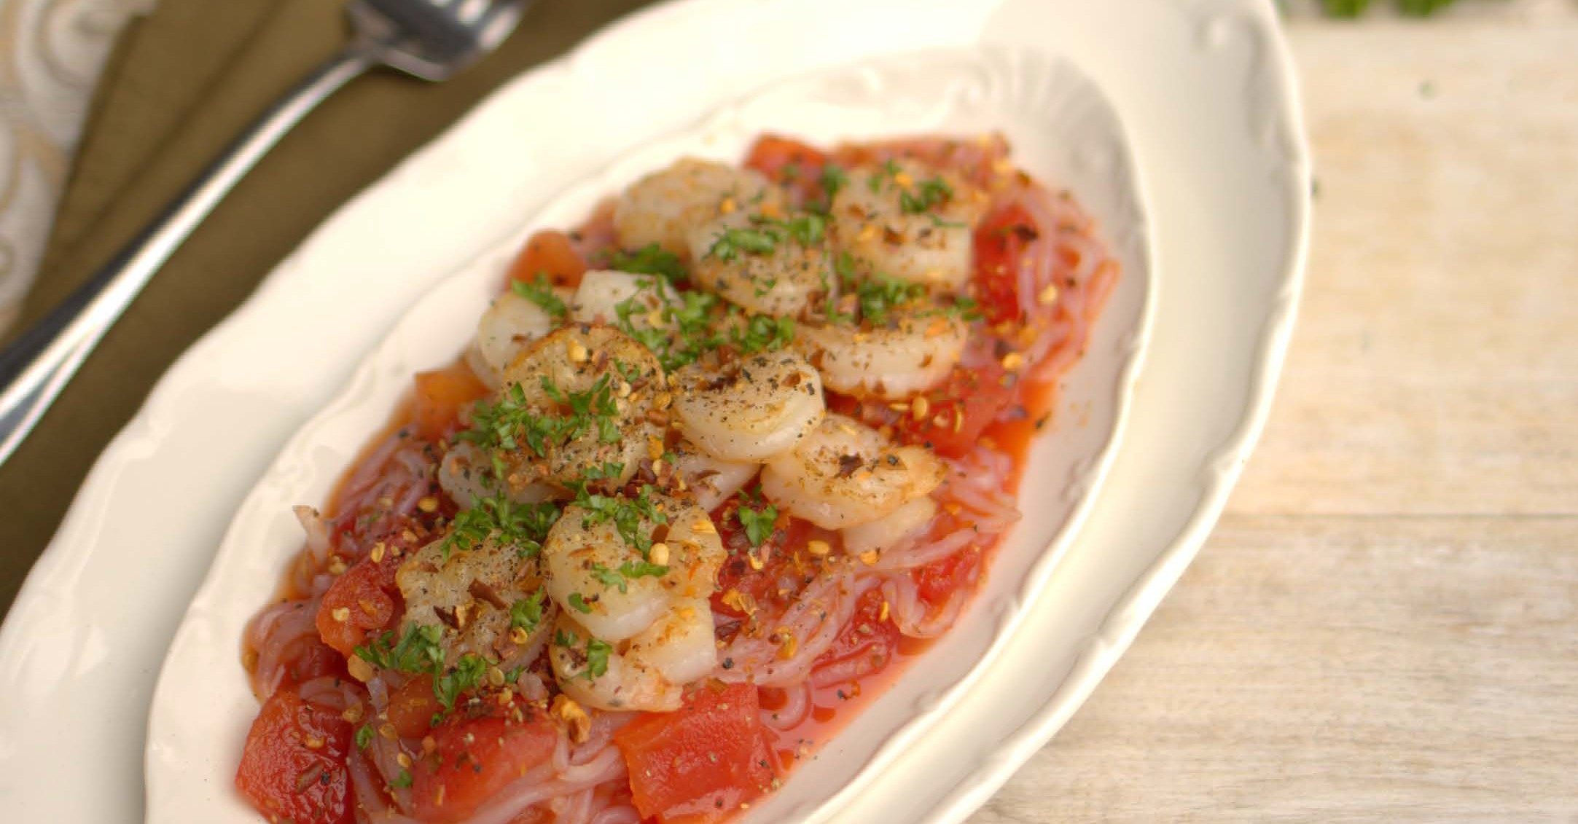

Halibut with Spring

Prep Time: 5 minutes Cook Time: 11 minutes Servings: 4

20 ounces halibut skinless, fillets
sea salt and pepper to taste coarse salt 2 tablespoons coconut oil
1 cup cabbage purple, diced
- bunch radishes (about 5), thinly sliced 1/2 small red onion thinly sliced
1/2 cup fresh flat-leaf parsley leaves 1/2 cup fresh cilantro leaves
- tablespoons lemon juice fresh
2 tablespoons olive oil extra-virgin plus more for drizzling
1/8 teaspoon nutmeg
- Season fillet on both sides with salt and pepper.
- Heat oil in a cast iron skillet to medium-high heat. Sear the halibut skin side down and do not move fillet for 8 minutes. Flip fillets and turn off heat. Continue to cook for 3 more minutes or until fish is cooked through, timing will depend on thickness.
- Meanwhile, combine vegetables and herbs in a large bowl and season with salt and pepper. Whisk lemon juice with oil and drizzle over salad, tossing to combine.
- Serve with halibut. Garnish salad with grated nutmeg and a drizzle of oil.
Nutritional Info (per serving)
Calories 297 | Fat 18g 55% | Protein 30g 40% | Carbs 4g 5% | Fiber 1g

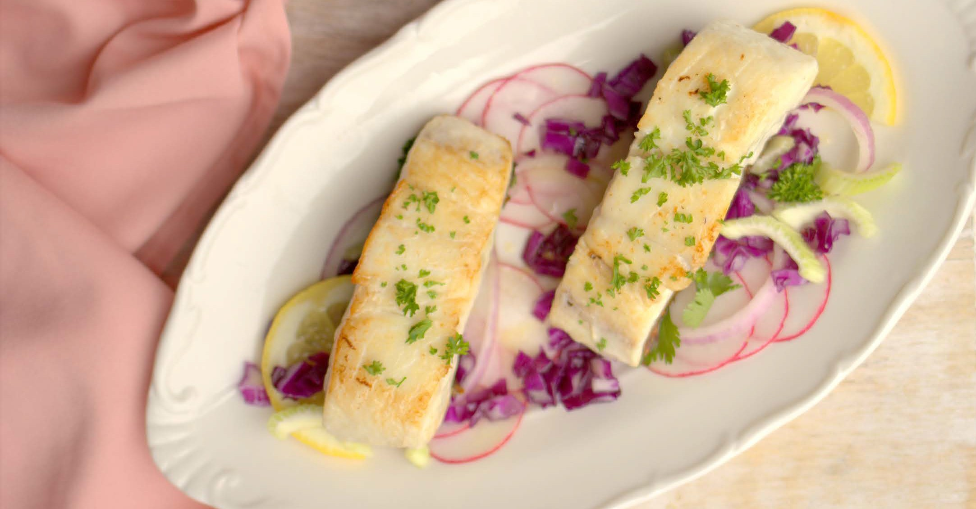

Walkin Tacos

Prep Time: 5 minutes Cook Time: 10 minutes Servings: 4

Tacos:
  - pound ground beef
  - tablespoons “Healthified” Taco Seasoning
4 tablespoons tomato sauce
4 cups pork rinds chicharrones; if using store bought, check for MSG
4 cups lettuce red leaf Garnish:
4 tablepsoons salsa
4 tablepsoons sour cream omit for dairy free 4 tablepsoons finely shredded hard cheese
omit for dairy free
- Place the beef in a cast iron skillet and sauté, while crumbling with a spatula, until no longer pink. Add the taco seasoning and tomato sauce. Mix well into the ground beef.
- Top the beef with shredded cheese to melt if using.
- Divide the pork rinds and lettuce between 4 plates. Top each with beef mixture. Garnish with salsa and sour cream if desired.

Nutritional Info (per serving)
Calories 380 | Fat 30g 71% | Protein 26g 27% | Carbs 2g 2% | Fiber 0 4g

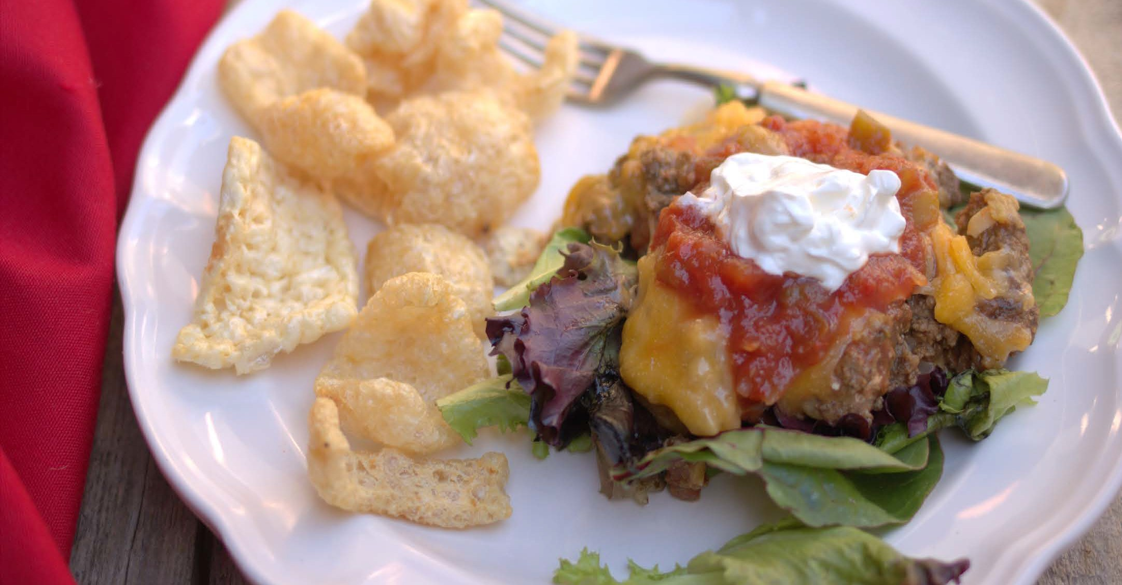

Deep Dish Dutch Baby Pizza

Prep Time: 5 minutes Cook Time: 18 minutes Servings: 2

- tablespoons coconut oil (or butter if not dairy sensitive)
- large eggs
3/4 cup unsweetened almond milk or cashew milk (hemp milk if nut free)
1/4 cup Jay Robb unflavored egg white protein powder
- teaspoon baking powder 1 teaspoon sea salt
- teaspoons italian seasoning
1/2 cup pizza sauce (check for added sugar) 1/2 cup mozzarella cheese (Nutritional
Yeast if dairy free)
1/4 cup Parmesan cheese (Nutritional Yeast if dairy free)
- Preheat oven to 425 degrees F (400 degrees F in convection ov- ens). In a medium cast iron skillet, place 2 tablespoons coconut oil. Place in hot oven.
- In a blender, combine the eggs, cashew milk, protein powder, baking powder, salt, and seasoning. Blend for about 1 minute or until foamy.
- Using an oven mit, remove the skillet from the oven. Pour the batter into the hot skillet. Bake for 10 minutes. Remove from oven and top with pizza sauce, cheese if using and any other pizza toppings you desire.
- Bake for about another 10 minutes or until the pizza crust is puffed and golden brown.
- Remove the pizza from the oven, cut into wedges and enjoy! Makes 2 servings.

Nutritional Info (per serving)
Calories 467 | Fat 35g 67% | Protein 33g 29% | Carbs 5g 4% | Fiber 1g

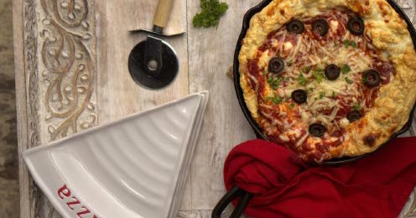

Open-Faced Chicken Pesto Sandwich

Prep Time: 10 minutes Cook Time: 20 minutes Servings: 1

2 medium Portobello mushrooms stems removed and chopped
1 chicken thighs pounded thin
sea salt and pepper to taste fine grain
3 tablespoons coconut oil melted; divided 1 clove garlic minced
TOPPINGS:
2 slices tomato
1 tablespoon basil mayo leafy greens
  - Heat oven to 400° F. Lightly grease medium baking dish; place mushroom caps in dish, gill-side down. Season with salt and pepper.
  - Bake mushroom caps 15-20 mins or until tender but not limp, turning once.
  - Pat the chicken thighs with paper towel to get off excess mois- ture. Using a heavy skillet, pound out chicken thighs to an even thickness of about ½ inch and season both sides well with pepper and salt.
  - Heat remaining 1 tablespoon oil in medium skillet over me- dium-high heat until hot. Cook chicken 4 minutes or until browned on one side. Turn; add mushroom stems and garlic to skillet. Cook until chicken is no longer pink inside. Remove chicken from pan and shred or slice into small 1 inch pieces.
  - Place mushroom caps gill side up on plates; top with a slice of tomato, diced chicken, basil mayo and lettuce.
Nutritional Info (per serving)
Calories 454 | Fat 42g 83% | Protein 17g 15% | Carbs 3g 2% | Fiber 1g

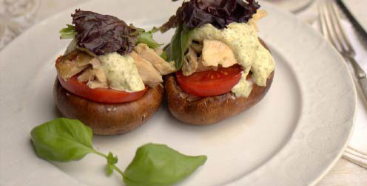

Chicken with Mushroom Gravy

Prep Time: 5 minutes Cook Time: 35 minutes Servings: 4

4 chicken thighs
1 teaspoon fresh ground black pepper 1/2 teaspoon sea salt fine grain
4 tablespoons butter (or other Paleo fat if dairy sensitive)
1 pound mushrooms sliced (button or baby Portobello)
1 clove garlic (or 1 teaspoon minced garlic)
3 tablespoons cream cheese (or coconut cream if dairy sensitive)
1/4 cup chicken bone broth (boxed will work, homemade preferred)
dried parsley for garnish
- Preheat oven to 400 degrees F. Season both sides of the chicken well with pepper and salt. Place the chicken in a roasting pan or baking sheet with edges. Bake for 20-25 minutes or until chicken is cooked through.
- Place butter in a cast iron skillet. Heat to medium-high. Add the mushrooms and cook until golden brown and soft, about 8 minutes. Add the garlic to the pan. Add the cream cheese and stock to the pan to deglaze. Use a whisk to scrape bits off the bottom of the pan.
- Remove chicken from oven and place on a serving platter. Serve chicken with drippings from the pan. Garnish with fresh chopped parsley.

Nutritional Info (per serving)
Calories 330 | Fat 26g 70% | Protein 20g 24% | Carbs 5g 6% | Fiber 2g

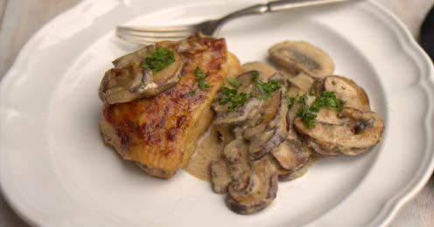

Filet Mignon With Olive Salad

Prep Time: 2 minutes Cook Time: 10 minutes Servings: 2

8 ounces filet mignon 1/2 tablespoon sea salt 2 slices bacon
- tablespoon paleo fat
- tablespoons shallots (or onions) 1 sprig fresh rosemary
1 cups olives mixed
feta cheese garnish; (omit if dairy free)
  - Heat a cast iron skillet to medium high heat with a tablespoon of paleo fat, shallots and rosemary. Pat the steak to dry and season well with pepper and salt.
  - Sear the steak in the hot oil on one side for 3 minutes, flip and sear the other side for another 3 minutes or until done to your desired liking (see chart below).
  - Basting steaks with a spoon. Thicker steaks will take longer. Turn steak on sides to sear the bacon until crisp all around the steak.
  - Remove steak from heat and set on a cutting board to rest.
  - Remove toothpick and place each steak on a plate.
  - Top with each steak olive salad and garnish with feta if using.
Recipe Notes
125 Degrees F = Rare
135 Degrees F = Medium Rare 145 Degrees F = Medium
Nutritional Info (per serving)
Calories 535 | Fat 45g 76% | Protein 28g 21% | Carbs 4g 3% | Fiber 2g

155 Degrees F = Medium Well 165 Degrees F = Well Done

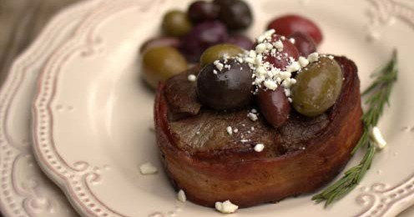

TANDOORI GRILLE D SHRIMP
WI TH RED CURRY DIPPING SAUCE

Prep Time: 20 minutes Cook Time: 25 minutes Servings: 2

1/2 cup lemon juice or lime
3 teaspoons garlic minced or 4 cloves minced
2 teaspoons fresh ginger grated 12 jumbo shrimp deveined
1/2 teaspoon cayenne pepper 1/2 teaspoon garam masala 1/4 teaspoon ground turmeric 1/4 teaspoon sea salt DIPPING SAUCE:
2/3 cup coconut milk
- teaspoon Thai red curry paste
1/3 cup chicken bone broth or chicken stock (homemade or boxed will work)
- tablespoons cilantro leaves and stems fresh
1 tablespoon basil leaves fresh 1 tablespoon fish sauce
1 teaspoon garlic minced; or one clove minced
1 teaspoon fresh ginger finely chopped 1 tablespoon lemon juice or lime
1/4 teaspoon sea salt
1/2 teaspoon fresh ground black pepper 1/2 teaspoon stevia glycerite (optional
sweetness)
- Preheat grill to medium-high heat. Place 4 wooden skewers in water to soak while you prep. Place the lime or lemon juice in a shallow baking dish. Add the garlic, ginger and shrimp. Mar- inade for 15 minutes while you prepare the spices and dipping sauce.
- Place ½ teaspoon cayenne pepper, ½ teaspoon garam masala, ¼ teaspoon turmeric and ¼ teaspoon salt in a small dish and stir well to combine. Set aside.
- Make the dipping sauce by placing all the ingredients in a small saucepan and heat on medium-high for 15 minutes or until sauce has thickened a bit. Remove from heat and set aside.
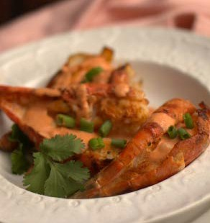
- Remove shrimp from marinade and liberally sprinkle with spice mixture. Thread 3 large shrimp onto each skewers. Grill for 3-4 minutes per side or until shrimp is pink and cooked through.

Nutritional Info (per serving)
Calories 272 | Fat 16g 53% | Protein 25g 37% | Carbs 7g 10% | Fiber 1g

Cilantro Lime Pork Chops

Prep Time: 10 minutes Cook Time: 15 minutes Servings: 6

20 ounces pork chop
sea salt and pepper to taste for seasoning
SAUCE:
- cup mayonnaise (or sour cream if not dairy-sensitive and/or egg-free)
1/4 cup fresh cilantro finely chopped 1/4 cup lime juice
- tablespoons fresh ginger grated
2 tablespoons chives chopped, fresh 1 teaspoon garlic finely chopped
1 jalapeño peppers seeded and coarsely chopped
1/2 teaspoon sea salt
  - Preheat grill to medium-high heat. Season both sides of pork chops with salt and pepper.
  - Sear the chops and cook on both sides until cooked through, about 3 1/2 minutes per side.
  - Serve each chop with 3 tablespoons sauce.
  - SAUCE: Meanwhile make the sauce by placing all the sauce ingredients in a food processor and puree until very smooth. Store in an airtight container in the refrigerator for up to 1 week. Shake well before using.

Nutritional Info (per serving)
Calories 521 | Fat 44g 76% | Protein 27g 21% | Carbs 3g 3% | Fiber 0 3g

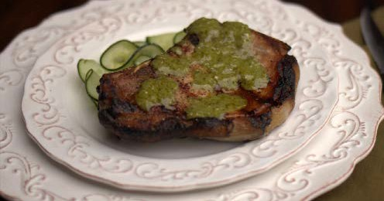

Cilantro Lime Slow Cooker Pork Short Ribs

Prep Time: 5 minutes Cook Time: 4-5 hours Servings: 8

4 pounds pork ribs
2 cups chicken bone broth or beef stock (boxed will work)
1/4 cup lime juice
1 teaspoon garlic minced
1 teaspoon sea salt fine grain SAUCE:
- cup mayonnaise (or sour cream if not dairy-sensitive and/or egg-free)
1/4 cup fresh cilantro finely chopped 1/4 cup lime juice
- tablespoons fresh ginger grated
2 tablespoons chives chopped; fresh
- Place the ribs inside a 4 quart slow cooker. Add 2 cups broth, lime juice, 1 teaspoon minced garlic and 1 teaspoon salt.
- Cook on high for 4-5 hours or on low for 7-8 hours.
- Meanwhile make the sauce by placing all the sauce ingredients in a food processor and puree until very smooth. Store in an airtight container in the refrigerator for up to 1 week. Shake well before using.
BUSY FAMILY TIP: Make extra and store them in air tight container until they day you want to eat.
When ready to consume, preheat the oven to broil. Re- move ribs from liquid (discard the liquid) and place ribs on cookie sheet with edges.
Baste the ribs in a few tablespoons of the sauce. Broil the ribs for 2 minutes or so, until bubbling and ribs get slight- ly crispy on the edges. Serve with extra sauce.

Nutritional Info (per serving)
Calories 665 | Fat 57g 78% | Protein 33g 20% | Carbs 2g  0 3% | Fiber 0 3g

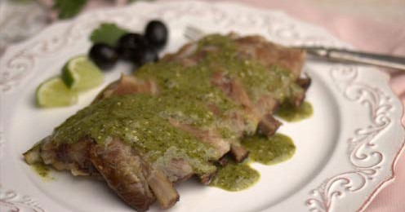

Hot and Spicy Chicken Chorizo Chili

Prep Time: 10 minutes Cook Time: 1 hour Servings: 8

  - tablespoon coconut oil
  - pounds chorizo sausage smoked; sliced
2 boneless skinless chicken thighs cut into
½ inch pieces
1 cup onion chopped
28 ounces tomatoes in can; whole peeled and undrained
3 chipotle peppers in adobo sauce 3 tablespoons garlic minced
2 tablespoons paprika smoked 1 tablespoon ground cumin
1 tablespoon ground dried oregano leaves 2 teaspoons sea salt fine grain
- teaspoon cayenne pepper
- cups chicken bone broth (boxed will work, homemade preferred)
12 ounces Lacroix lime carbonated beverage in can
1 ounce unsweetened baking chocolate chopped
1/4 cup lime juice fresh 1/4 cup fresh cilantro
- Heat a large soup pot over medium high heat. Add the oil, cho- rizo, diced chicken and onions. Cook until onions are soft and chicken is cooked through, about 5 minutes.
- Meanwhile, place the tomatoes with juice and chilis in a food processor. Combine until smooth. Set aside.
- Add garlic, paprika, cumin, oregano, salt and cayenne to the soup pot and saute for another minute while stirring.
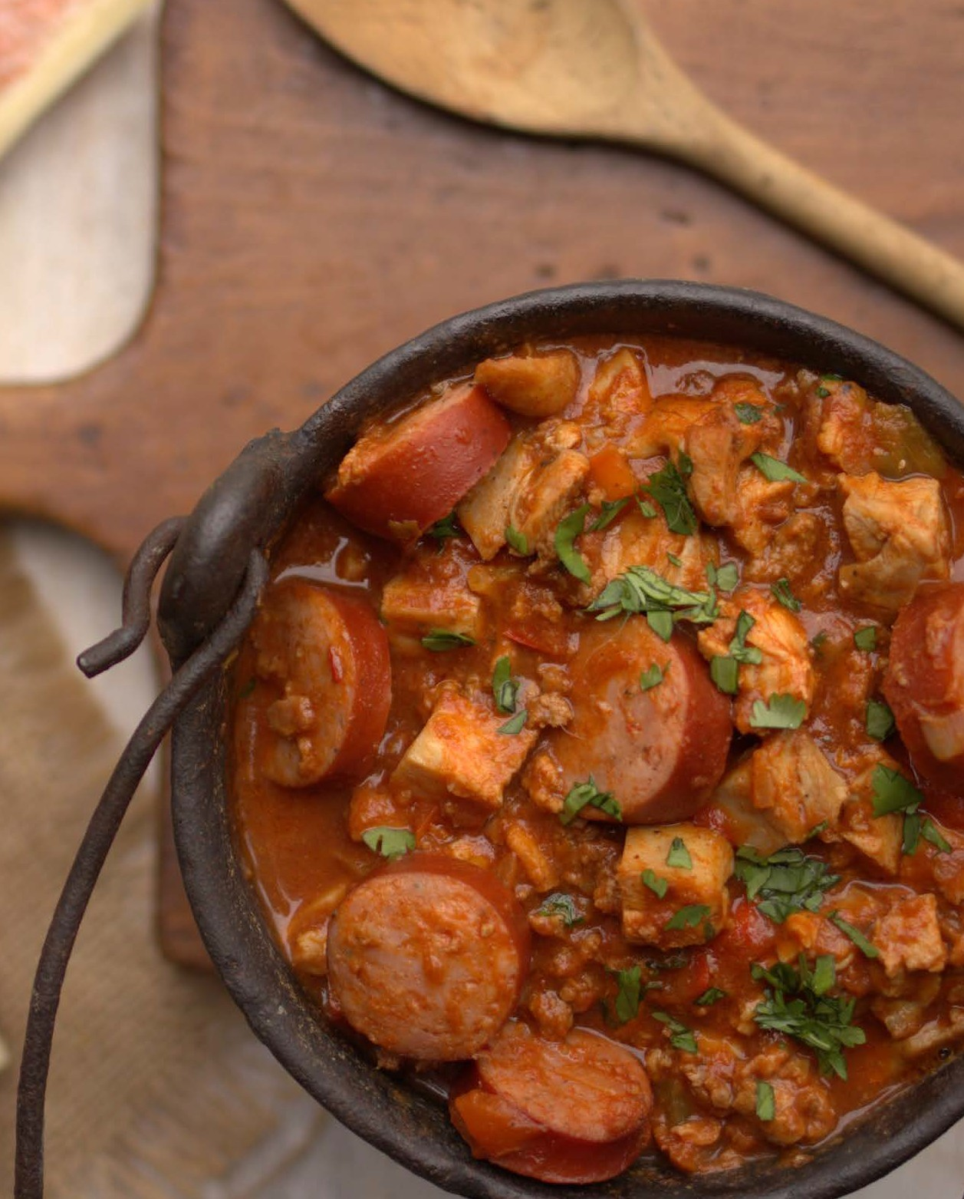
- Add in the tomato puree, broth, Lacroix, chopped chocolate. Heat until a soft boil then reduce heat to low and cook for 1 hour for flavors to open up. Just before serving, stir in lime juice and cilantro.

Nutritional Info (per serving)
Calories 437 | Fat 34g 70% | Protein 21g 19% | Carbs 11g 10% | Fiber 3g

Trout Provencale en papillote

Prep Time: 10 minutes Cook Time: 15 minutes Servings: 4

2 whole trout with skin, butterflied (NOTE: I asked my butcher to do this for me)
2 tablespoons MCT oil
- teaspoon sea salt fine gain
1/2 teaspoon fresh ground black pepper
- teaspoons duck fat (or butter if not dairy sensitive)
6 sprigs fresh thyme
6 sprigs fresh rosemary 2 slices lemon
2 teaspoons capers
sea salt and pepper to taste
- Preheat the oven to 400 degrees F. Place each fish on a piece of greased parchment paper.
- Drizzle the fish generously with MCT oil and season well with salt and pepper.
- Open the trout up. Season inside with salt and pepper. Place herbs, lemon slices and capers in the center with a teaspoon of duck fat or butter.
- Wrap the fish tightly in the parchment by folding in the sides then folding in the long edges. Lay seal side down onto a bak- ing sheet with edges. Place in oven and bake for 13-15 minutes (depending on how thick your trout is).
- Make the hollanda

Nutritional Info (per serving)
Calories 206 | Fat 14g 62% | Protein 17g 33% | Carbs 2g 4% | Fiber 1g

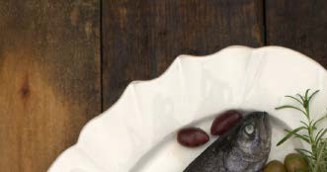

Lamb and Mushroom Kabobs

Prep Time: 10 minutes Cook Time: 15 minutes Servings: 12

Marinade:
1 leg of lamb boneless (about 4 pounds) 1/2 cup MCT oil or quality olive oil
1/4 cup lemon juice
6 cloves garlic minced 1/2 cup onion chopped
1/4 cup mint leaves chopped fresh
1 tablespoon fresh oregano leaves, chopped
Kabobs:
1 onion cut into 2-inch squares
1 red bell pepper cut into 2-inch squares 1 pint cherry tomatoes stemmed
8 ounce package button mushrooms white
- To marinade the lamb, cut the lamb into 1 1/2 by 1 1/2 inch cubes. Place cubes in a shallow dish. Combine all the marinade ingredients and pour over the lamb. Cover and marinade for at least 2 hours. Overnight is best.
- Remove lamb from refrigerator. Preheat grill to medium. And soak wooden skewers (or long rosemary stems in water for 30 minutes.
- Assemble by placing a cube of lamb, followed by a mushroom (or any other addition you desire, such as cherry tomatoes, bell peppers) onto the skewers or long rosemary stems. Repeat until lamb is used.
- Place skewers on preheated grill for about 6-7 minutes, rotating 1/2 way through, or until done to your desired preference.

Nutritional Info (per serving)
Calories 316 | Fat 19g 54% | Protein 32g 40% | Carbs 5g 6% | Fiber 1g

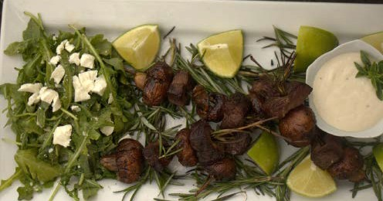


Desserts



Mexican Chocolate SemiFreddo

Prep Time: 15 minutes
Cook Time: 5 minutes plus chill Servings: 8

6 ounces unsweetened baking chocolate chopped fine
2 teaspoons cinnamon
2 teaspoons vanilla extract
3/4 teaspoon sea salt ine grain, divided
- 1/2 cups heavy cream or coconut cream for dairy free
- large egg whites room temperature 2/3 cup Confectioners Swerve
- Place the chopped chocolate, cinnamon, vanilla, and 1/2 tea- spoon salt in a medium heatproof bowl.
- Heat cream in a small saucepan over medium until barely sim- mering. Pour hot cream over chocolate mixture and let sit until chocolate is melted, about 5 minutes. Whisk chocolate mixture until combined and smooth. Stir in the natural sweetener.
- Chill, stirring occasionally, until cold, about 1 hour.
- Beat the eggs whites until stiff to make a meringue.
- Using an electric mixer, beat chilled chocolate mixture until soft peaks form. Gently fold in meringue, leaving a few streaks.
- Place a piece of parchment paper into a large loaf pan. Scrape into a large loaf pan and cover. Freeze until solid, at least 3 hours and up to 3 days.

Nutritional Info (per serving)
Calories 395 | Fat 39g 89% | Protein 4g  4% | Carbs 7g 7% | Fiber 5g
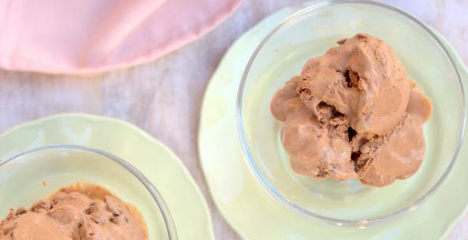

Chocolate Cheesecake Trifle

Prep Time: 8 minutes Cook Time: 45 minutes Servings: 12

ANGEL FOOD CAKE:
12 large egg whites
2 teaspoon cream of tartar 1 pinch sea salt
1 cup Jay Robb Vanilla Protein Powder or chocolate egg white protein powder
1 cup Confectioners Swerve or powdered erythritol
1 cup unsweetened cocoa powder
1 teaspoon chocolate extract or other extract
Cheesecake:
16 ounces cream cheese 2 packages or 2 mascarpone cheese
3/4 cup cashew milk or unsweetened almond milk (hemp milk if nut free)
3/4 cup Confectioners Swerve
1/2 cup unsweetened cocoa powder 1 teasepoon vanilla extract
1/2 teasepon sea salt fine grain
- Angel Food Cake: Preheat oven to 350 degrees F (175 degrees C). Sift protein powder, cocoa powder and confectioners Swerve together and set aside. In a large clean bowl, whip egg whites with a pinch of salt until foamy.
- Add cream of tartar and continue to beat until very stiff (you will be able to put bowl upside down and the whites won’t fall out).
- Add your favorite extract flavor. Quickly fold in protein powder mixture.
- Pour into a greased 10 inch tube pan. Bake at 350 degrees F (175 degrees C) for 45 minutes.
- Trifle: Cut the angel food cake into 1 inch pieces.
- In a large bowl combine softened cream cheese and Swerve. Add the unsweetened cashew milk, cocoa powder, vanilla and salt. Combine until smooth. Taste and adjust sweetness to your de- sired liking.
- Place the angel food cake pieces in a large clear trifle bowl about 2 inches high. Top with 1/4 of the cream cheese mixture. Repeat 3 more times.

Nutritional Info (per serving)
Calories 245 | Fat 16g 59% | Protein 16g 26% | Carbs 9g 15% | Fiber 3g

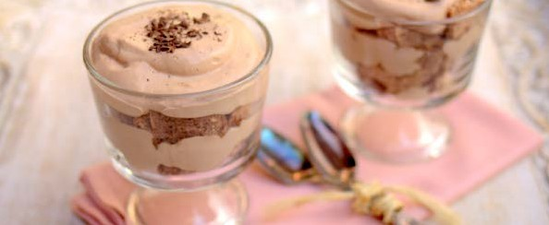

Chai Tea Breakfast Custard

Prep Time: 4 minutes Cook Time: 1-3 minutes Servings: 4

1 cup coconut milk full-fat; (or heavy cream if not dairy-sensitive)
1 tablespoon gelatin grass-fed powdered
- cup chai tea strong brewed (1 cup water steeped with 2 chai tea bags)
1/2 cup Confectioners Swerve sweetener or equivalent
- teaspoons cinnamon
1 teaspoon vanilla extract or seeds scraped from 1 vanilla bean (about 6 inches long)
1/8 teaspoon sea salt
- Pour the coconut milk into a medium-sized bowl. Sift the gelatin over the milk and let it soften while you prepare the rest of the ingredients.
- Heat 1 cup of strong brewed chai tea in a saucepan over medium heat for a few minutes or until hot. Alternatively, heat the milk in a microwave-safe container in the microwave for a minute.
- Whisk the sweetener and cinnamon into the cool coconut milk gelatin mixture. Stir until well combined.
- Pour the hot coconut milk into the gelatin mixture while stir- ring constantly. Add the extract and salt. Pour the custard into four 4-ounce serving cups. Place in the refrigerator for 1 hour or until the custard is set. Best served at room temperature but can be served cold.
Nutritional Info (per serving)
Calories 105 | Fat 8g 69% | Protein 4g 15% | Carbs 4g 15% | Fiber 1g



Vanilla bean cupcakes

Prep Time: 7 minutes Cook Time: 10 minutes Servings: 12

CUPCAKES:
2 large eggs
4 tablespoons sour cream
- tablespoons coconut oil or butter, softened
1/2 cup Confectioners Swerve plus stevia glycerite to taste
- tablespoons coconut flour 1 teaspoon baking powder
1/4 teaspoon sea salt fine grain FROSTING:
1/2 stick butter unsalted, softened 1/4 cup cream cheese
2 tablespoons Confectioners Swerve
1 vanilla bean scraped clean (or 2 teaspoons vanilla)
pinch sea salt fine grain
  - Cupcakes: Preheat oven to 325 degrees F. Grease two 12 hole mini muffin tins and set aside.
  - In a large bowl combine the eggs, sour cream, softened butter and Swerve. Add stevia glycerite to your desired sweetness (about 1 teaspoon, the sweetness is reduced after baking). Mix until well combined. Add the coconut flour, baking powder and salt. Stir well to combine.
  - Place mixture into the greased muffin tins. Bake for 10-12 min- utes or until a toothpick inserted into the middle comes out clean.
  - FROSTING: Meanwhile make the frosting by combining all the frosting ingredients. Adjusting sweetness to your desired liking.
  - One the cupcakes are finished baking, cool completely before frosting.
  - Frost and enjoy! Store extras in an airtight container in the fridge for up to 5 days.

Nutritional Info (per serving)
Calories 130 | Fat 13g 90% | Protein 2g  7% | Carbs 1g 3% | Fiber 1g



Chocolate Angel food Cake

Prep Time: 10 minutes Cook Time: 45 minutes Servings: 14

12 large egg whites
2 teaspoon cream of tartar 1 pinch sea salt
1 cup Jay Robb Vanilla Protein Powder or chocolate egg white protein powder
1 cup Confectioners Swerve sweetener (or powdered erythritol)
1 cup unsweetened cocoa powder
1 teaspoon chocolate extract (or other extract)
- Preheat oven to 350 degrees F (175 degrees C). Sift protein pow- der, cocoa powder and confectioners Swerve together and set aside. In a large clean bowl, whip egg whites with a pinch of salt until foamy (save the yolks for “healthified” creme anglaise, OR “healthified” ice cream for the topping).
- Add cream of tartar and continue to beat until very stiff (you will be able to put bowl upside down and the whites won’t fall out).
- Add your favorite extract flavor. Quickly fold in whey mixture.
- Pour into a greased 10 inch tube pan. Bake at 350 degrees F (175 degrees C) for 45 minutes.
Nutritional Info (per serving)
Calories 61 | Fat 1g 15% | Protein 10g 66% | Carbs 3g 19% | Fiber 1g

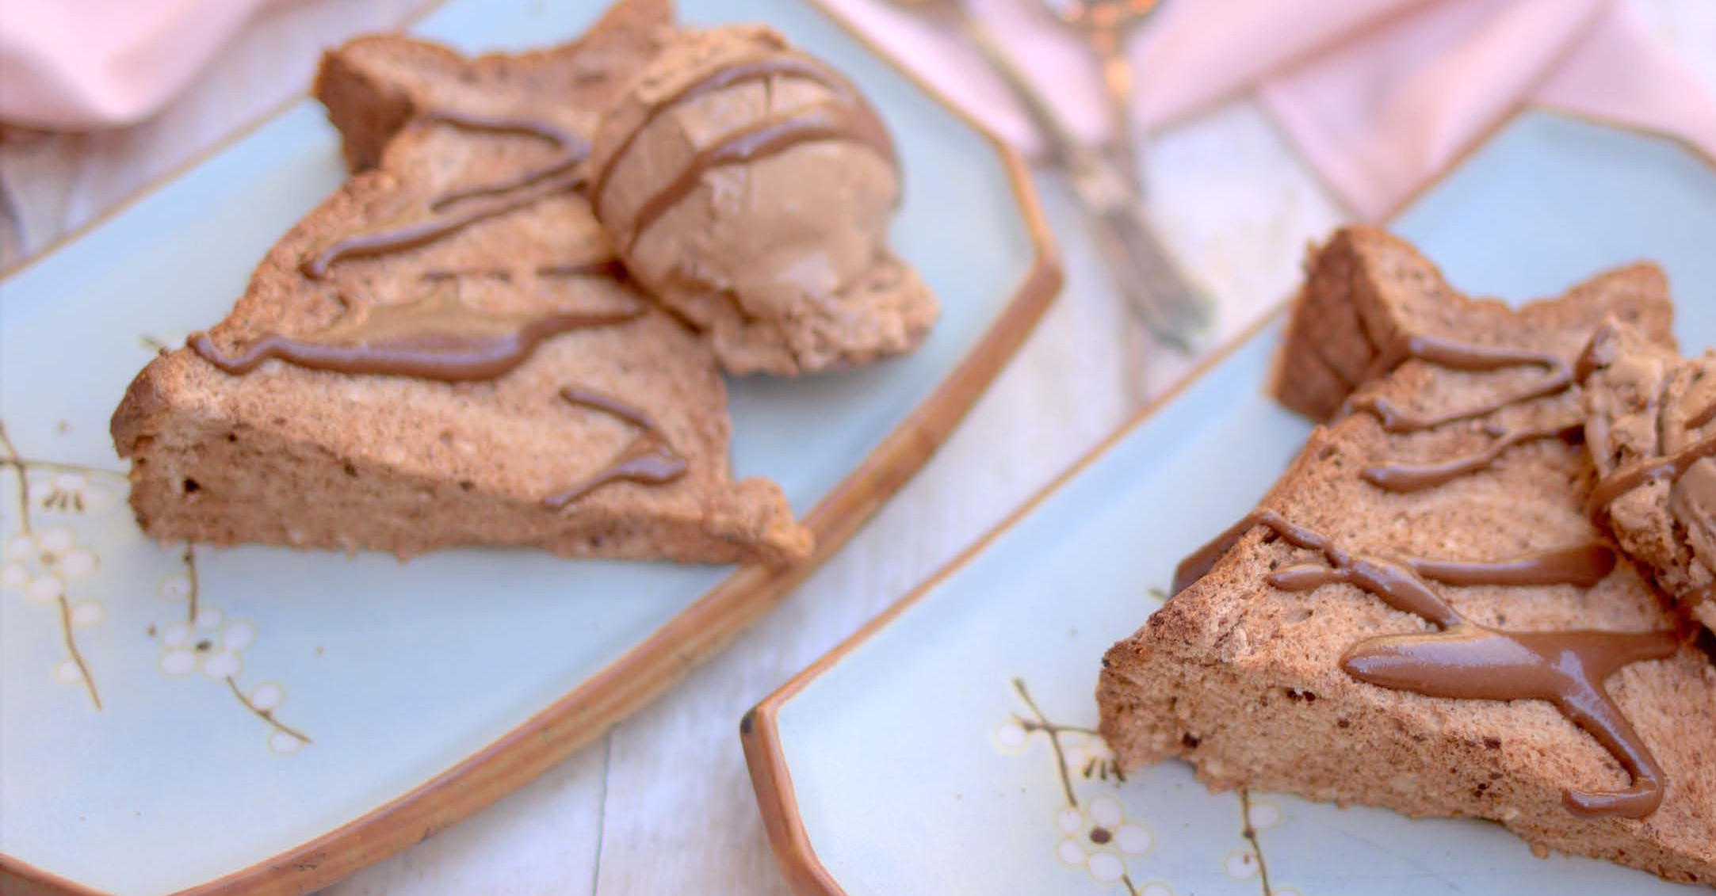

Easy Flourless Cookies

Prep Time: 5 minutes Cook Time: 10 minutes Servings: 12

1 cup almond butter pecan butter, macadamia nut butter
1/2 cup Confectioners Swerve 1 teaspoon stevia glycerite
1 large egg
1/4 teaspoon sea salt fine grain 1 teaspoon vanilla extract
- Preheat oven to 350 degrees F.
- Place all the ingredients in a bowl and combine until smooth. Add “healthified” pieces of chocolate if desired.
- Place 2 tablespoons of dough about 2 inches apart on a cookie sheet. Press down a bit with fingers or a fork.
- Bake for 8-10 minutes or until slightly golden brown on the edges.

Nutritional Info (per serving)
Calories 135 | Fat 11g 73% | Protein 5g 15% | Carbs 4g 12% | Fiber 2g
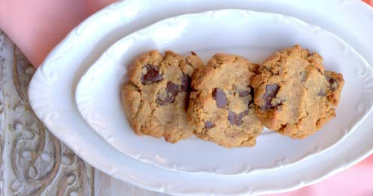

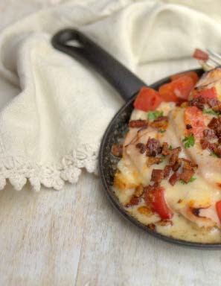

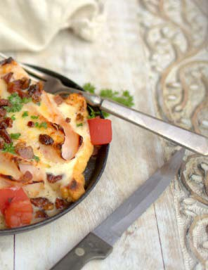
MealPlans

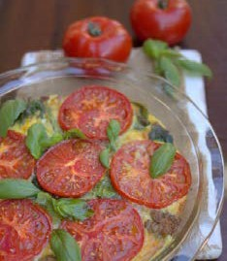
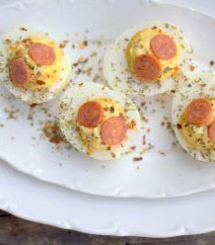
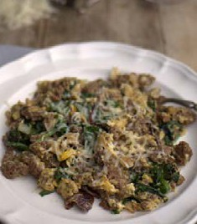
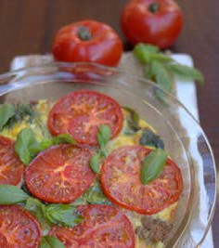
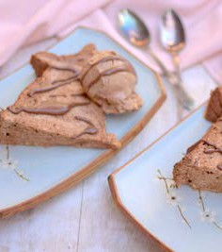
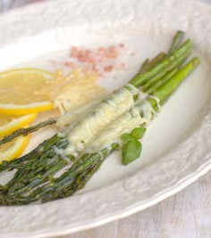
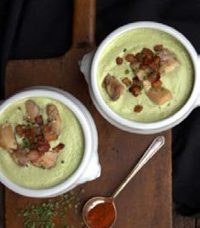
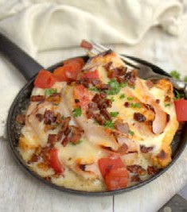
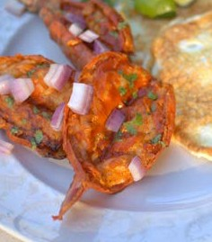
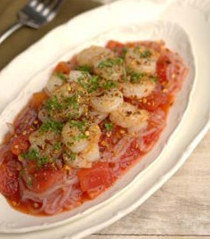
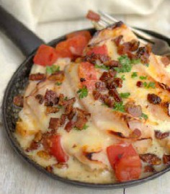
Meal Plan Week 1

Day 1 |  |  |  |  | Day 2 |  |  |  |  | Day 3 |  |  |  |  | Day 4
Begin Eating Window |  |  |  |  | Begin Eating Window |  |  |  |  | Begin Eating Window |  |  |  |  | Begin Eating Window
Eggs Florentine Casserole  Servings: 4  Nutritional Info (per serving) |  |  |  |  | Pizza Deviled Eggs  Servings: 4  Nutritional Info (per serving) |  |  |  |  | Gyro Breakfast Patties  Servings: 12  Nutritional Info (per serving) |  |  |  |  | Eggs Florentine Casserole  (leftover)  Servings: 4  Nutritional Info (per serving)
calories  491 | fat  38g 71% | protein 32g  26% | carbs 4g 3% | fiber  1g | calories  642 | fat  61g 86% | protein 19g 12% | carbs 3g 2% | fiber  0g | calories  345 | fat  26g  68% | protein 26g  30% | carbs 1g 2% | fiber  0.3g | calories  491 | fat  38g 71% | protein 32g  26% | carbs 4g 3% | fiber  1g
Snack or Dessert |  |  |  |  | Snack or Dessert |  |  |  |  | Snack or Dessert |  |  |  |  | Snack or Dessert
Chocolate Angel food Cake  Servings: 14  Nutritional Info (per serving) |  |  |  |  | Parmesan Basil Asparagus  Servings: 4  Nutritional Info (per serving) |  |  |  |  | CREAMY CHICKEN SOUP  Servings: 6  Nutritional Info (per serving) |  |  |  |  | Chocolate Angel food Cake (leftover)  Servings: 14  Nutritional Info (per serving)
calories  61 | fat  1g 15% | protein 10g 66% | carbs 3g 19% | fiber  1g | calories  360 | fat  26g  65% | protein 26g  29% | carbs 6g 6% | fiber  3g | calories  362 | fat  28g 69% | protein 22g 24% | carbs 8g 8% | fiber  5g | calories  61 | fat  1g 15% | protein 10g 66% | carbs 3g 19% | fiber  1g
End Eating Window |  |  |  |  | End Eating Window |  |  |  |  | End Eating Window |  |  |  |  | End Eating Window
Kentucky Hot Brown  Servings: 12  Nutritional Info (per serving) |  |  |  |  | Camaron en Chile Rojo  Servings: 6  Nutritional Info (per serving) |  |  |  |  | Shrimp Arrabbiata  Servings: 4  Nutritional Info (per serving) |  |  |  |  | Kentucky Hot Brown  Servings: 12  Nutritional Info (per serving)
calories  720 | fat  63g 79% | protein 35g 19% | carbs 3g 2% | fiber  0.1g | calories  299 | fat  18g 54% | protein 22g 30% | carbs 12g  16% | fiber  3g | calories  225 | fat  9g 36% | protein 29g 52% | carbs 7g 12% | fiber  2g | calories  720 | fat  63g 79% | protein 35g 19% | carbs 3g 2% | fiber  0.1g
Day 1 Totals |  |  |  |  | Day 2 Totals |  |  |  |  | Day 3 Totals |  |  |  |  | Day 4 Totals
calories  1322 | fat  105g  72% | protein 83g 25% | carbs 10g 3% | fiber  2.1g | calories  1301 | fat  105g  73% | protein 67g 20% | carbs 21g 7% | fiber  6g | calories  932 | fat  63g 60% | protein 77g 33% | carbs 16g 7% | fiber  7.3g | calories  1322 | fat  105g  72% | protein 83g 25% | carbs 10g 3% | fiber  2.1g

Meal Plan Week 1 cont.

Note:
This meal plan will have extra servings at the end of the week. So you can either repeat until leftovers
Day 5 |  |  |  |  | Day 6 |  |  |  |  | Day 7
Begin Eating Window |  |  |  |  | Begin Eating Window |  |  |  |  | Begin Eating Window
2 Eggs and  2 strips of Bacon  Servings: 1  Nutritional Info (per serving) |  |  |  |  | Pizza Deviled Eggs  (lefover)  Servings: 4  Nutritional Info (per serving) |  |  |  |  | Gyro Breakfast Patties  Servings: 12  Nutritional Info (per serving)
calories  473 | fat  39g  78% | protein 22g 20% | carbs 0g 0% | fiber  0g | calories  642 | fat  61g 86% | protein 19g 12% | carbs 3g 2% | fiber  0g | calories  345 | fat  26g  68% | protein 26g  30% | carbs 1g 2% | fiber  0.3g
Snack or Dessert |  |  |  |  | Snack or Dessert |  |  |  |  | Snack or Dessert
Asparagus  Cobb Salad  Servings: 4  Nutritional Info (per serving) |  |  |  |  | Vanilla bean cupcakes  Servings: 12  Nutritional Info (per serving) |  |  |  |  | CREAMY CHICKEN SOUP  (leftover)  Servings: 6  Nutritional Info (per serving)
calories  335 | fat  26g  70% | protein 19g 23% | carbs 6g  7% | fiber  2g | calories  130 | fat  13g 90% | protein 2g  7% | carbs 1g 3% | fiber  1g | calories  362 | fat  28g 69% | protein 22g 24% | carbs 8g 8% | fiber  5g
End Eating Window |  |  |  |  | End Eating Window |  |  |  |  | End Eating Window
Cilantro Lime Pork Chops  Servings: 6  Nutritional Info (per serving) |  |  |  |  | Salmon with Crispy Skin and Green Goddess Dressing  Servings: 4  Nutritional Info (per serving) |  |  |  |  | Halibut with  Spring Salad  Servings: 4  Nutritional Info (per serving)
calories  521 | fat  44g  76% | protein 27g 21% | carbs 3g 3% | fiber  0.3g | calories  385 | fat  28g 65% | protein 33g  34% | carbs 0.3g  1% | fiber  0.1g | calories  297 | fat  18g 55% | protein 30g 40% | carbs 4g 5% | fiber  1g
Day 5 Totals |  |  |  |  | Day 6 Totals |  |  |  |  | Day 7 Totals
calories  1474 | fat  125g  77% | protein 68g 19% | carbs 9g 3% | fiber  2.3g | calories  1296 | fat  117g  81% | protein 54g  17% | carbs 4g 2% | fiber  1.1g | calories  1004 | fat  72g  65% | protein 78g 31% | carbs 13g 5% | fiber  6.3g

are done or freeze them for another week.

Grocery List Week 1

Baking Produts
Baking powder 1 teaspoon
Beef broth or water 1 3/4 cup
Chicken bone broth 4 cups
Coconut flour 3 tablespoons
Coconut vinegar 1 tablespoon
Cream of tartar 2 teaspoons
Lemon juice 8 teapsoons
Lime juice 5 tablespoons
Unsweetened cocoa powder 1 cup

Canned Items
Pizza sauce 1 teaspoon
Tomato paste 2 tablespoons

Condiments
Organic mayo 2 1/3 cup

Dairy
Cream cheese 8 ounces
Parmesan cheese 1 1/2 cups
Sharp cheddar cheese 28 ounces
Sour cream 1/4 cups

Eggs
Egg whites 12 large
Eggs 36 large

Fats and Oils
Bacon fat 1 tablespoon
Butter 1 3/4 cups
Coconut oil 3/4 cup
MCT oil 1/4 cups
Olive oil 2 tablespoons
Paleo fat 1/3 cups

Fresh Herbs
Basil leaves (1 1/8 cups) 2 bunch
Chives 2 sticks
Fresh cilantro 1 bunch
Fresh flat-leaf parsley 1 bunch
Fresh ginger 1 bunch

Milk and Drinks
Unsweetened almond milk 0.25 cups

Produce
Asparagus 32 ounces
Avocado 2
Cabbage (1 cup shredded) 1 head
Diced tomatoes 14.50 ounces
Garlic 14 cloves
Habanero peppers 2
Jalapeño peppers 2
Lemon 4 slices
Limes 6 key
Radishes 1 bunch
Red fresno peppers 4
Red onion 1 small
Spinach 1 cup
Tomatoes 3 ripe
Yellow onion 2 medium

Protein Powder
Jay Robb unflavored egg white 1/4 cups
Jay Robb Vanilla Protein Powder 1 cup

Proteins
Bacon 18 strips
Chicken thighs 16 ounces
Ground lamb sausage 2.50 pounds
Ground pork 24 ounces

Halibut 20 ounces
Ham 1 cup diced
Pepperoni (mini) 1 package
Pork chop 20 ounces
Salmon fillets 24 ounces
Shrimp 24 ounces
Turkey 24 slices

Spices and Extracts
Anchovy paste 1/2 teaspoon
Cayenne pepper 1/2 teaspoon
Chocolate extract 1 teaspoon Crushed red pepper flakes 1 teaspoon Dried basil 1/2 teaspoon
Dried chives 1/2 teaspoon
Dried dill weed 1/2 teaspoon
Dried parsley 1/2 teaspoon Fresh ground black pepper 1/2 teaspoon Garlic powder 1/2 teaspoon
Ground dried oregano 1 teaspoon
Italian seasoning 2 teaspoon
Nutmeg 1/4 teaspoon
Onion powder 1 teaspoon
Sea salt 3 tablespoons
Vanilla bean 1

Sweeteners
Confectioners Swerve 1 3/4 cups

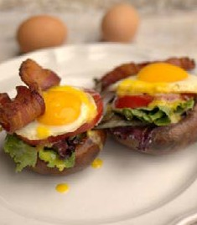
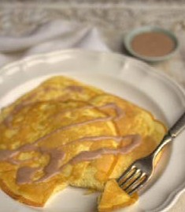
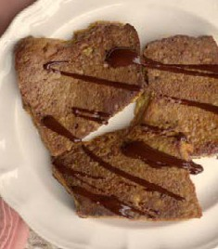
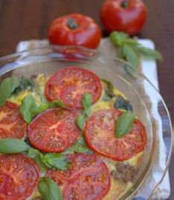
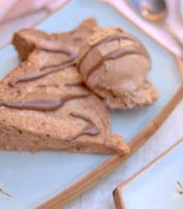
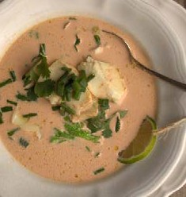
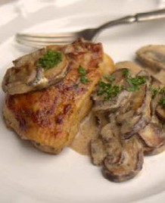
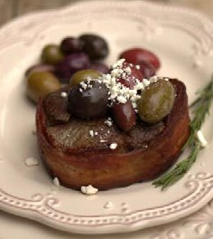
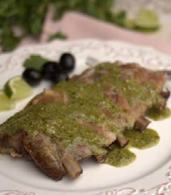
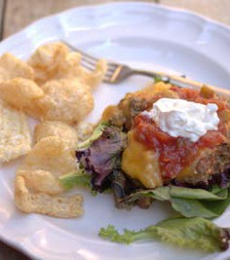
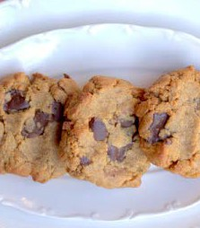
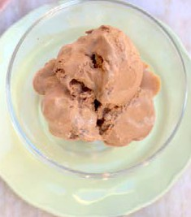
Meal Plan Week 2

Day 1 |  |  |  |  | Day 2 |  |  |  |  | Day 3 |  |  |  |  | Day 4
Begin Eating Window |  |  |  |  | Begin Eating Window |  |  |  |  | Begin Eating Window |  |  |  |  | Begin Eating Window
Open Faced Breakfast Sandwich  Servings: 1  Nutritional Info (per serving) |  |  |  |  | Dairy Free & Nut Free Pancakes  & Syrup  Servings: 2  Nutritional Info (per serving) |  |  |  |  | Chocolate  French Toast  Servings: 7  Nutritional Info (per serving) |  |  |  |  | Eggs Florentine Casserole  Servings: 4  Nutritional Info (per serving)
calories  509 | fat  45g 80% | protein 24g  19% | carbs 2g 1% | fiber  0.4g | calories  299 | fat  26g  78% | protein 13g 17% | carbs 3.4g  5% | fiber  1g | calories  340 | fat  22g 58% | protein 26g  31% | carbs 9g 11% | fiber  4g | calories  491 | fat  38g 71% | protein 32g  26% | carbs 4g 3% | fiber  1g
Snack or Dessert |  |  |  |  | Snack or Dessert |  |  |  |  | Snack or Dessert |  |  |  |  | Snack or Dessert
Chocolate Angel food Cake  (or leftover  from week1)  Servings: 14  Nutritional Info (per serving) |  |  |  |  | Halibut Red Curry  Servings: 4  Nutritional Info (per serving) |  |  |  |  | Easy Flourless Cookies  Servings: 8  Nutritional Info (per serving) |  |  |  |  | Mexican Chocolate SemiFreddo  Servings:  Nutritional Info (per serving)
calories  61 | fat  1g 15% | protein 10g 66% | carbs 3g 19% | fiber  1g | calories  333 | fat  21g 58% | protein 27g 33% | carbs 8g 9% | fiber  1g | calories  135 | fat  11g 73% | protein 5g 15% | carbs 4g 12% | fiber  2g | calories  395 | fat  39g  89% | protein 4g 4% | carbs 7g  7% | fiber  5g
End Eating Window |  |  |  |  | End Eating Window |  |  |  |  | End Eating Window |  |  |  |  | End Eating Window
Chicken with Mushroom Gravy  Servings: 4  Nutritional Info (per serving) |  |  |  |  | Filet Mignon With  Olive Salad  Servings: 2  Nutritional Info (per serving) |  |  |  |  | Cilantro Lime Slow Cooker Pork Short Ribs  Servings: 8  Nutritional Info (per serving) |  |  |  |  | Walkin Tacos  Servings: 4  Nutritional Info (per serving)
calories  330 | fat  26g  70% | protein 20g 24% | carbs 5g 6% | fiber  2g | calories  535 | fat  45g 76% | protein 28g 21% | carbs 4g 3% | fiber  2g | calories  665 | fat  57g 78% | protein 33g  20% | carbs 2g 2% | fiber  0.3g | calories  380 | fat  30g 71% | protein 26g  27% | carbs 2g 2% | fiber  0.4g
Day 1 Totals |  |  |  |  | Day 2 Totals |  |  |  |  | Day 3 Totals |  |  |  |  | Day 4 Totals
calories  1221 | fat  107g  79% | protein 54g  18% | carbs 10g 3% | fiber  3.4g | calories  1167 | fat  92g 71% | protein 68g 23% | carbs 15g 5% | fiber  4g | calories  1201 | fat  91g 68% | protein 74g 25% | carbs 18g 6% | fiber  6.3g | calories  1266 | fat  107g  76% | protein 62g 20% | carbs 13g 4% | fiber  6.4g

Meal Plan Week 2 cont.

Note:
This meal plan will have extra servings at the end of the week. So you can either repeat until leftovers
Day 5 |  |  |  |  | Day 6 |  |  |  |  | Day 7
Begin Eating Window |  |  |  |  | Begin Eating Window |  |  |  |  | Begin Eating Window
2 Eggs and  2 Sausages  Servings: 1  Nutritional Info (per serving) |  |  |  |  | Eggs Florentine Casserole  (leftover)  Servings: 4  Nutritional Info (per serving) |  |  |  |  | Chocolate French Toast (leftover)  Servings: 7  Nutritional Info (per serving)
calories  343 | fat  31g 80% | protein 17g 19% | carbs 1g 1% | fiber  0g | calories  491 | fat  38g 71% | protein 32g  26% | carbs 4g 3% | fiber  1g | calories  340 | fat  22g 58% | protein 26g  31% | carbs 9g 11% | fiber  4g
Snack or Dessert |  |  |  |  | Snack or Dessert |  |  |  |  | Snack or Dessert
Easy Flourless Cookies  (leftover)  Servings: 8  Nutritional Info (per serving) |  |  |  |  | Mexican Chocolate SemiFreddo (leftover)  Servings:  Nutritional Info (per serving) |  |  |  |  | Buffalo Chicken Wings  with sauce  Servings: 6  Nutritional Info (per serving)
calories  135 | fat  11g 73% | protein 5g 15% | carbs 4g 12% | fiber  2g | calories  395 | fat  39g  89% | protein 4g 4% | carbs 7g  7% | fiber  5g | calories  611 | fat  50g 74% | protein 40g 26% | carbs 0.4g  1% | fiber  0.1g
End Eating Window |  |  |  |  | End Eating Window |  |  |  |  | End Eating Window
Deep Dish Dutch Baby Pizza  Servings: 2  Nutritional Info (per serving) |  |  |  |  | Tandoori Grilled Shrimp with Red Curry Sauce  Servings: 2  Nutritional Info (per serving) |  |  |  |  | Hot & Spicy Chicken Chorizo Chili  Servings: 8  Nutritional Info (per serving)
calories  467 | fat  35g 67% | protein 33g  29% | carbs 5g 4% | fiber  1g | calories  272 | fat  16g 53% | protein 25g 37% | carbs 7g 10% | fiber  1g | calories  437 | fat  34g  70% | protein 21g 19% | carbs 11g 10% | fiber  3g
Day 5 Totals |  |  |  |  | Day 6 Totals |  |  |  |  | Day 7 Totals
calories  945 | fat  77g 73% | protein 55g 23% | carbs 10g 4% | fiber  3g | calories  1158 | fat  93g 73% | protein 61g 21% | carbs 18g 6% | fiber  7g | calories  1388 | fat  106g  69% | protein 87g 25% | carbs 20g 6% | fiber  7.1g

are done or freeze them for another week.

Grocery List Week 2

Baking Prod- ucts
Baking powder 1/2 tablespoon
Chicken bone broth 6 cups
Coconut milk 24 ounces
Coconut vinegar 4 teaspoons
Cream of tartar 2 teaspoons
Fish sauce 3 teaspoons
Lemon juice 3/4 cup
Lime 1 whole
Lime juice 3/4 cups
Pork rinds 4 cups
Unsweetened baking chocolate 9 ounces Unsweetened cocoa powder 1 cup

Canned Items
Almond butter 1 cup
Olives 1 cup
Pizza sauce 1/2 cups
Tomato sauce 1/4 cups

Condiments
Dijon mustard 1 tablespoon
Hot pepper sauce 3/4 cups
Mayonnaise 1 cup
Salsa 4 tablepsoons
Thai red curry paste 5 teaspoons

Dairy
Cream cheese 9 teaspoons
Feta cheese garnish
Finely shredded hard cheese 4 tablepsoons
Heavy cream 2 1/2cups
Mozzarella cheese 1/2 cups
Parmesan cheese 1/4 cups
Sour cream 4 tablepsoons

Eggs
Egg whites 15 large
Egg yolks 3 large
Eggs 24 large

Fats and Oils
Butter 1 1/4 cup
Coconut oil 1 1/3 cups
MCT oil 1 tablespoon
Paleo fat 2 tablespoons

Fresh Herbs
Basil leaves (1 cup) 1 bunch
Chives 1 stalk
Cilantro leaves and stems 1 bunch
Fresh cilantro (3/4 cup) 1 bunch
Fresh ginger 1 inch piece
Fresh rosemary 1 sprig

Milk and Drinks
Lacroix lime beverage 12 ounces Unsweetened almond milk 1 3/4 cups

Produce
Chipotle peppers 3
Garlic 7 clove
Green onions 1/4 cups
Jalapeño peppers 1
Lettuce (4 cups) 1 head
Mushrooms 16 ounces
Onion 1 large
Portobello mushrooms 2 medium
Shallots 4
Spinach (1 cup) 1 bag
Tomatoes 28 ounces

Protein Powder
Jay Robb unflavored egg white 1/4 cups
Jay Robb Vanilla Protein Powder 1 cup

Proteins
Bacon 4 slices
Boneless skinless chicken thighs 6 Breakfast sausage 2 links
Chicken wings 32 ounces
Chorizo sausage 32 ounces
Filet mignon 8 ounces
Ground beef 16 ounces
Ground pork 16 ounces
Halibut 16 ounces
Pork ribs 64 ounces
Shrimp 12 jumbo

Spices and Extracts
“Healthified” Taco Seasoning 2 tablespoons
Almond extract 1/2 teaspoon
Cayenne pepper 2 teaspoons
Chocolate extract 1 teaspoon
Cinnamon 1 tablespoon
Dried parsley garnish Fresh ground black pepper 4 teaspoons Garam masala 1/2 teaspoon
Garlic powder 1 teaspoon
Ground cinnamon 1 teaspoon
Ground cumin 1 tablsepoon
Ground dried oregano 1 tablsepoon
Ground turmeric 1/2 teaspoon
Italian seasoning 2 teaspoons
Maple extract 1 teaspoon
Paprika 2 tablespoons
Sea salt 1/4 cup
Sea salt and pepper to taste
Vanilla bean 1 bean
Vanilla extract 4 teaspoons

Sweeteners
Confectioners Swerve 3 1/2 cups
Stevia glycerite 2 1/2 teaspoons

